**Smart Pointers:**

**General notes:**

1. Issues with Raw pointers.
2. Unique pointer will not share the common heap storage.
3. Shared pointer will share the common heap storage.
4. All smart pointers are about ownership and RAII(Resource acquisition and init initialization).
5. Custom deleters.

**Issues with Raw pointers:**

1. c++ provides absolute flexibility with memory management.

1. Allocation
2. De-allocation
3. Lifetime management.

1. Some potentially serious problems:

1. Uninitialized (wild) pointers).(pointing to anywhere in the memory)
2. Memory leaks(Allocated memory is never deallocated)
3. Dangling pointers (one pointer is pointing to a storage which is already been deallocated, i.e pointer is pointing to invalid memory. It will cause problems.
4. Not Exception safe

**Smart pointers are:**

1. Objects.

1. Can only point to heap allocated memory.

1. Automatically call delete when no longer needed.

1. Adhere to RAII principles.

1. C++ smart pointers: (header , #include <memory>
   1. Defined by class templates
      * It’s a wrapper around a smart pointer.
      * Overloaded operators:
        1. Deference (*)
        2. Member selection (->)
        3. Pointer arithmetic not supported(++,--,etc).
   2. Can have custom deleters.

i) Unique pointers(unique_ptr)

ii) Smart pointers(smart_ptr)

iii) Weak pointers (weak_ptr).

iv) Auto pointers (auto_ptr)

**Shared Pointers: (Need not to call delete for shared ptrs)**

1. Provides shared ownership of heap objects.

b) shared_ptr<T>

1. Points to an object of type T on the heap
2. It's not unique, there can be multiple shared ptrs pointing to the same object on heap.
3. Establishes shared ownership relationship.
4. Can be assigned and copied.
5. Can be moved.
6. Does not support managing arrays by default.
7. When use count is zero, managed object is automatically destroyed.

Smart Pointers:

1. A simple example:

{

Std::smart_poiner<some_class> ptr = ..

Ptr->method();

Cout << (*ptr) << endl;

}

//here ptr will be destroyed automatically when nolonger needed (i.e smart pointer destructor is called automatically and memory allocation on heap will be deleted).

RAII – Resource Acquisition is Initialization:

* 1. Common idiom or pattern used in software design based on the container object lifetime
  2. RAII objects are allocated on the stack.
  3. Resource Acquisition
     1. Open a file
     2. Allocate Memory
     3. Acquire a lock.
  4. Is initialization (the resource is acquired in a constructor).
  5. Resource relinquishing:
     1. Happens in the destructor: a) Close the file. b) Deallocate memory c) Release the lock.

1. Unique Pointer (unique_ptr): A Simple smart pointer , very efficient.

**unique_ptr<T>:**

a) points to an object of type T on the heap.

b) it is unique, there can only be a one unique ptr pointer pointing to the object on the heap.

c) Owns what is points.

d) It cannot be copied or assigned.

e) Can be Moved.

f) When the pointer is destroyed, what it points to is automatically destroyed.

Unique ptr declaration: (some useful methods):

{

Std::unique_ptr<int> p1 { new int {100}};

std::cout << *p1 << endl; //100

cout << p1.get() << endl; // ox5b6212 (

*p1 = 200;

Std::cout << *p1 << std::endl;

P1.reset() ; // p1 is now null ptr.// Memory will be released.

If(p1) {

Std::cout << *p1 << endl

}

}//automatically deleted.

{

Unique_ptr – vectors and move:

Std::vector<unqiue_ptr<int>> vec;

Std::unique_ptr<int>. p1 {new int {100}};

Vec.push_back(ptr); //Error – copy not allowed.

Vec.push_back(std::move(ptr));

} //automatically deleted.

Better way to initialize the smart pointers ( unique_ptr – make_unique (C++14)).

{

Std::unique_ptr<int> p1 = make_unique<int>(100);

Std::unique_ptr<Account> p2 = make_unique<Account>(“Curly”, 5000);

Auto p3 = make_unique<Player>(“Hero”,100,100);

}//automatically deleted.

//For a vector of uniqueptrs, when iterating it, we need to give const reference:

Std::vector<unique_ptr<Accout>> v1;

For(const auto &acc: v1);

unique_ptr<T> does not allow copy construction, instead it supports move semantics. Yet, I can return a unique_ptr<T> from a function and assign the returned value to a variable.

#include <iostream>

#include <memory>

using namespace std;

unique_ptr<int> foo()

{

unique_ptr<int> p( new int(10) );

return p; // 1

//return move( p ); // 2

}

int main()

{

unique_ptr<int> p = foo();

cout << *p << endl;

return 0;

}

**Copy Elision:**

**Shared Pointers:**

Provides shared ownership of heap objects.

Shared_ptr<T>:

a) Points to an object of type of T on the heap.

b) It is not unique – there can be multiple shared_ptrs pointing same object on the heap.

c) Establishes shared ownership relationship.

d) Can be assigned and copied.

e) Can be moved also.

f) Does not support managing arrays by default.

g) When the use count or use reference count is zero , the managed object on the heap is destroyed.

g) **When you declare a smart pointer object, that object is placed on the**

**h) shared_ptr will provide a get method automatically.**

**Creation, initialization & using:**

{

Std:shared_ptr<int> {new int {100}};

cout << p1.use_count() << endl; //1

Std::cout << *p1 << endl; //100.

*p1 = 200 (shared pointer will allow us to modify) but whereas unique ptr wil not allow

Std::shared_pt<int> p2 {p1};

cout << p1.use_count() << endl; //2

cout << p2.use_count() << endl; //1

p1.reset(); decrement the use_count; p1 is nulled out, p1 use count will 0

cout << p1.use_count() << endl; //0

cout << p2.use_count() << endl; //1

Std::cout << *p1 << endl; //200.

} // p1 and p2 are automatically deallocated.

//Shared pointers with user defined classes:

{

Std::shared_ptr<Account> p1 { new Account {“shankar”, 100}};

Std::cout << *p1 << endl; //display account

P1->deposit(1000);

P1->withdraw(500)

}//Automatically deleted.

//Shared pointers vectors and move:

{

Std::vector<std::shared_ptr<int>> vec;

Std::shared_ptr<int> p1 { new int {100}};

Vec.push_back(p1); // Ok – Copy IS allowed, here there is one more reference is created to the integer object

Std::cout << p1.use_count() <<endl; //2

}

**//Better way of creating and initializing: (make_shared(C++)):**

{

Std::shared_ptr<int>. p1 = std::make_shared<int> (100);

Std::shared_ptr<int>. p2 {p1}; //Copy constructor is called.

Std::shared_ptr<int>. p3;

P3 =p1;

}

Use make_shared – more efficient

All 3 pointer point to the same object on the heap.

When the use_count becomes 0 the heap object is deallocated.

**Note:std::enable_shared_from_this:**  allows an object t that is currently managed by a [std::shared_ptr](https://en.cppreference.com/w/cpp/memory/shared_ptr) named pt to safely generate additional [std::shared_ptr](https://en.cppreference.com/w/cpp/memory/shared_ptr) instances pt1, pt2, ... that all share ownership of t with pt.

Publicly inheriting from std::enable_shared_from_this<T> provides the type T with a member function shared_from_this.

std::enable_shared_from_this allows an object t that is currently managed by a [std::shared_ptr](https://en.cppreference.com/w/cpp/memory/shared_ptr) named pt to safely generate additional [std::shared_ptr](https://en.cppreference.com/w/cpp/memory/shared_ptr) instances pt1, pt2, ... that all share ownership of t with pt.

Publicly inheriting from std::enable_shared_from_this<T> provides the type T with a member function shared_from_this. If an object t of type T is managed by a [std::shared_ptr](http://en.cppreference.com/w/cpp/memory/shared_ptr)<T> named pt, then calling T::shared_from_this will return a new [std::shared_ptr](http://en.cppreference.com/w/cpp/memory/shared_ptr)<T> that shares ownership of t with pt.

**WEAK_PTR**:

a) Provides a non-owning “weak” reference

Weak_Ptr<T>

a) Points to an object of type T on the heap

b) Does not participate in owning relationship.

c) Always created from a shared_ptr

d) Does not increment or decrement the reference use count.

e) Used to prevent strong reference cycles which could prevent objects from being deleted.

🡪 Circular or Cyclic Reference:

a) A refers to B

b) B refers to A

c) Shared strong ownership prevents heap deallocation.

A. B

Shared_ptr<B> ----------🡪

🡨-----------shared_ptr<A>

**Custom deleters:**

1) Sometimes when we destroy a smart pointer, we need more than a way to destroy the object on the heap.

2) these are special use-cases.

3) C++ smart pointers allow you to provide custom deleters.

4) Lots of way to achieve this.

a) functions.

Ex: here my_deleter will be automatically called, when the smartpointer goes out of the scope.

Void my_deleter(some_class *raw_pointer){

delete raw_pointer;

}

Shared_ptr<some_class> ptr { new some_class {}, my_deleter };

b) lambdas

c) Others.

*#include <iostream>*

*#include <memory>*

***using******namespace*** *std;*

***class*** *Test{*

***private****:*

***int*** *a;*

***public****:*

*Test(****int*** *i):a(i){*

*cout << "Parameter construtor is called" << endl;*

*}*

*};*

***void*** *mydeleter(Test* t){*

*cout << "Deleter is invoked for test object" << endl;*

***delete*** *t;*

*}*

***int*** *main(){*

*//We cannot use make_shared here.*

*{*

*shared_ptr<Test> sh {****new*** *Test(10), mydeleter};*

*}*

*{*

*Shared_ptr<Test>. Pt1 (new Test(100), [](Test *t) { cout << “delete is called through lambda” << endl; delete t;});*

*}*

A *default constructible class* is a class that has a default constructor (either its implicit constructor or a custom defined one).  
  
The is_default_constructible class inherits from [integral_constant](http://www.cplusplus.com/integral_constant) as being either [true_type](http://www.cplusplus.com/true_type) or [false_type](http://www.cplusplus.com/false_type), depending on whether T is default constructible.

**Design Principles:**

1) Single Responsibility Principle:

The **single**-**responsibility principle** (SRP) is a computer-programming **principle** that states that every module or class should have **responsibility** over a **single** part of the functionality provided by the software, and that **responsibility** should be entirely encapsulated by the class, module or function.

Ex: Suppose a class is there which will have entries for Jounals(journtal title, multiple entries) and if we have one more function to store the all the journal entries. Here instead of having a function to store the journal entries inside the sam function of the class, create a separate class for that.

**SingleTon Design Pattern:**

1. For some components it only makes sense to have one object in the system:
   1. Database repository
   2. Object repository
2. E.g constructor call is expensive a) we only do it once , b) we provide everyone with the same instance.
3. Want to prevent anyone creating additional copies.
4. Need to take are of lazy instantiation and thread safety.

**Singleton:** A component which is instantiated only once.

Rules:

a) private constructor.

b) To avoid creating objects with the copy constructor and assignment operator , declare below section in the public space of class:ex: class name is Student

Student(Student const&) = delete;

Void operator=(Student const&) = delete;

c) A method which return the reference of the object in public:

static Student& const(){

static Student s;

return s;

}

Flow Control basically means that **TCP** will ensure that a sender is not overwhelming a receiver by sending packets faster than it can consume. It's pretty similar to what's normally called **Back pressure** in the Distributed Systems literature

<https://nlohmann.github.io/json/doxygen/classnlohmann_1_1basic__json_a4c734aac1ea36f4b62f25308b6c6784a.html#a4c734aac1ea36f4b62f25308b6c6784a>

**Binary Search Tree:**

**Binary Search Tree** is a node-based binary tree data structure which has the following properties:

* The left subtree of a node contains only nodes with keys lesser than the node’s key.
* The right subtree of a node contains only nodes with keys greater than the node’s key.
* The left and right subtree each must also be a binary search tree.

The above properties of Binary Search Tree provide an ordering among keys so that the operations like search, minimum and maximum can be done fast. If there is no ordering, then we may have to compare every key to search a given key.

**Insertion of a key:**

A new key is always inserted at leaf. We start searching a key from root till we hit a leaf node. Once a leaf node is found, the new node is added as a child of the leaf node.

In a **Binary Search Tree** (**BST**), all keys in left subtree of a key must be smaller and all keys in right subtree must be greater. So a **Binary Search Tree** by definition **has** distinct keys and **duplicates** in **binary search tree** are not allowed.

**Time Complexity:**The worst case time complexity of search and insert operations is O(h) where h is height of Binary Search Tree. In worst case, we may have to travel from root to the deepest leaf node. The height of a skewed tree may become n and the time complexity of search and insert operation may become O(n).

**Threads and Processes**

**Process:** A process is a running instance of an application or a computer program that is being executed.

When a process is started, memory is allocated in the RAM and instructions for this process will be fetched to the Processor. So a running instance is called as process

**Context:** Collection of data about process which allows processor to suspend or hold the execution of a process and restart the execution later.

This data is : Memory addresses and Program Counter states.

If a single Processor is there and multiple processes are there. Processer executes the processes(or instructions) in a round robin/time slot basis, like running one, and hold/pause the other process. This is nothing but Context Switching.

**Thread:** thread of execution is a smallest sequence of programmed instructions that can be managed independently by a Scheduler.

Thread is a component of process. Every process has at least one thread called main thread which is the entry point of the program.

The main difference between threads and processes is “threads (of same process) run in a shared memory space, while processes run in a different Memory Space.

In Modern systems, there are multiple Cores (or processors) are there, so multiple threads run in parallel without the Context Switching.

There are 2 types of Parallelism:

a) Task Level Parallelism: Different task on same or different area.

b) Data Level Parallelism: Same task on different data.

Concurrency Vs Parallelism:

a) Multiple processes are there, but a single processor is there. So processor executes the processes one after the other using the context Switching, this is called as Concurreny. But here an illusion is provided to the user of parallelism.

b) if multiple processes are there, and multiple cores(or multi processors) are available , then its called as Parrallelism. But if no. processes out number the no. of core, then it will be again referred as Concurrency.

**Creating a thread : header “#include <thread>”:**

a) a function pointer.

void foo(params){

}

std::thread thread_obj(foo, params)

b) A function Object.

auto f = [](params){

// do something

};

Or

Class callable{

Public:

Void operator()(){

Cout << “function object” << endl;

}

}

std::thread thread_obj(f, params)

c) A lamda expression

we can also pass lamda functions directly to the constructor.

std::thread thread_object([] (params) { //do something};,params);

**Joinable:**

a) A properly constructed thread object represent an active thread of execution in the hardware level. Such a thread object is joinable.

b) For a joinable thread , we must call either JOIN or DETACH. After making this call, thread will become non joinable.

c) If you forgot to JOIN or DETACH on a joinable thread, then at the time of destructor call to that thread object, std::terminate will be called.

d) If any program have std::terminate call we refer such program as “unsafe program”.

Ex: //this wil give an error.

Void test(){

Cout << “hello world” << endl;

}

Int main(){

Std::thread t1(test);

}

**JOIN:**

a) Join introduces a “synchronize point” between launched thread and thread that it launched from.

b) It “blocks the execution” of the thread that calls join function, until the launched thread’s execution finished.

**DETACH:**

Detach separtes the launched thread from the thread object which is being launched from, allowing execution to continue independently.

Any allocated resources will be freed once the thread exits.

x

**Better Joining Mechanism:**

We can call detach function as soon as we launch a thread, as “detach” call does not block the calling thread.

b) In some cases we cannot call “join” as soon as we launch a thread, as join call block the calling thread.

c) If there are some of operations b/w the creation of thread and join of threads. If the those (in b/w) operations throw exception, join will be skipped, it’s a unsafe programming.

/\**void otherOperations(){*

*cout << "This is Operations function" << endl;*

*throw std::runtime_error("this is runtime error");*

*};*/*

/*

*std::thread t1(FunctionA);*

*otherOperations();*

*cout << "After the detach" << endl;*

*t1.join();*

*cout << "After the join" << endl; */*

*WorkAround1: (But this is not programming)*

*/*std::thread t1(FunctionA);*

*try{*

*otherOperations();*

*cout << "After the detach" << endl;*

*t1.join();*

*}catch(…){*

*T1.join()*

*cout << "After the join" << endl; */*

*} */*

d) RAII (Resource acquisition is initialization – constructor acquire resources, destructor releases resources). By using this, we can provide better joining mechanism.

**Passing Parameters to the thread objects:**

Default (1)– thread() noexcept;

Initialization(2) – template<class fn, class… Args>

Explicit thread (Fn&& fn, Args&&… args);

Copy[deleted](3) // thread(const thread&) =delete;

Move[4]. // thread(thread&& x) noexcept;

**Pass parameters by value:**

Int fun1(int x, int y)

Std::thread t1(fun1,a,b);

**Pass parameters by ref:**

Int fun1(int &x, int &y)

Std::thread t1(fun1,std::ref(a),std::ref(b));

**Problems while passing parameters/objects by ref in threads:**

We should be careful when we are passing values to threads by reference and detaching that thread. Because in main thread, that variable might go out of scope and destructor should have called.

**Important Notes for threads:**

**Note:** Thread objects are not copy constructable or it’s a movable.

So , std::thread t1(foo);

Std::thread t2 = t1; //Not allowed, as threads not copy constuctable,

Std::thread t3 = std::move(t1); // allowed as it is movable.

**Useful Functions in threads:**

a) std::this_thread:get_id(), print the id of the current thread.

b) std::thread t1(foo);

t1.get_id();

get_id(), will return 0, if its called on default constructed thread or join in already executed.

c) sleep_for , this will sleep or make the current thread to be paused for specificied no. of times.

Std::this_thread::sleep_for(std::chrono::milliseconds(5000));

d) std::yield() or std::this_thread::yield(): Yield will give up the current time slice and re-insert the thread into the scheduling queue. The amount of time that expires the thread until the thread is executed again is usually entirely depend upon the scheduler.

e) Hardware Concurrency: Returns the no. of concurrent threads supported by the implementation. The value should be considered as a hint.

If there are more threads in application compared to the no. of cores in the hardwares,processor has to execute threads in a Round robin or scheduling way.

*Std::thread::hardware_concurrency(); //returns no. of cores in the hardware*

**Parallel accumulate Algorithm:**

Std::accumulate , sums of all elements passed to it by being and end iterators with default value,

Ex: std::accumulate(v1.begin(), v1.end(), <default value>)

Std::accumulate(v1.begin(), v1.end(), <default value>, binaryPredicate);

Std::vector<int> v1 {1,2,3,4,5,6,7,8,9,10};

Int sum = std::accumulate(v1.begin(),v1.end(),0);

Int product = std::accumulate(v1.begin(),v1.end(),1, std::multiplies<int>());

**InBound Concept “Invariants”:**

a) Most common problem of the multithreaded applications is , broken invariants while updating.

**Mutex:** (Mutual exclusion, it’s a synchronization primitive which is used to control the access to shared data).

Lock: Locks the mutex, blocks if the mutex is not available.

Try_lock: tries to lock the mutex, returns if the mutex is not available.

Unlock: Unlocks the mutex

Above 3 are public member functions.

x

std::mutex m;

{

m.lock();

int I = 5;

m.unlock();

}

If you forgot to unlock mutex, old thread will be in waiting state.

So there will be issues , if you forgot to unlock the mutex, so lock_guard will provide a better mechanism.

**Mutex:**

The mutex class is synchronization primitive that can be used to protect shared data from being simultaneously accessed by multiple threads.

1. its defined in the header <mutex>, and with class as "std::mutex"

1. Mutex offers exclusive and non-recursive ownership semantics:

a) A Calling thread owns a mutex from the time that is successfully calls either lock or try_lock until it calls unlock.

b) When thread owns a mutex, all other threads will block(for calls to lock) or receive a false return value (for try_lock) if they attempt to claim ownership of a mutex.

c) A calling thread must not own the mutex prior to calling lock or try_lock.

**Note:** the behaviour of the program is undefined, if a mutex is destroyed while still it is owned by threads or a thread terminates while owning a mutex.

d) std::mutex is neither copyable nor movable.

Functions : constructor and destructor, Locking: lock, try_lock, unlock , Native Handle: native_handle.

**Note: std::mutex is not usually not accessed directly , std::unique_lock, std::lock_guard, or std::scoped_lock(since c++17) , manage locking in a more exception safe manner.**

**Std::mutex vs std::unique_lock:**

Yes, the std::unique_lock calls unlock on the mutex in its destructor.

The benefit of this is that in case some exception is thrown, you are sure that the mutex will unlock when leaving the scope where the std::unique_lock is defined.

**Lock_guard Class:**

a) The class lock_guard is a mutex wrapper that provides convenient RAII-style mechanism for owning a mutex for the duration of the scoped block.

b) When a lock_guard object is created, it attempts to take the ownership of the mutex given. When control leaves the scope in which the lock_guard object was created, the lock_guard is destructed and mutex is released.

Std::mutex m;

{

Std::lock_guard<std::mutex> lg(m);

}

**Ex:** List is not a thread safe data structure.

**Recursive mutex:**

A *recursive mutex* is a [*lockable object*](http://www.cplusplus.com/Lockable), just like [mutex](http://www.cplusplus.com/mutex), **but allows the same thread to acquire multiple levels of ownership over the *mutex object*.**  
This allows to [*lock*](http://www.cplusplus.com/recursive_mutex::lock) (or [*try-lock*](http://www.cplusplus.com/recursive_mutex::try_lock)) the *mutex object* from a thread that is already locking it, acquiring a new level of ownership over the *mutex object*: the *mutex object* will actually remain locked owning the thread until its member [unlock](http://www.cplusplus.com/recursive_mutex::unlock) is called as many times as this level of ownership.

The recursive_mutex class is a synchronization primitive that can be used to protect shared data from being simultaneously accessed by multiple threads.

recursive_mutex offers exclusive, recursive ownership semantics:

* A calling thread owns a recursive_mutex for a period of time that starts when it successfully calls either [lock](https://en.cppreference.com/w/cpp/thread/recursive_mutex/lock) or [try_lock](https://en.cppreference.com/w/cpp/thread/mutex/try_lock" \o "cpp/thread/mutex/try lock). During this period, the thread may make additional calls to [lock](https://en.cppreference.com/w/cpp/thread/recursive_mutex/lock) or [try_lock](https://en.cppreference.com/w/cpp/thread/recursive_mutex/try_lock" \o "cpp/thread/recursive mutex/try lock). The period of ownership ends when the thread makes a matching number of calls to [unlock](https://en.cppreference.com/w/cpp/thread/recursive_mutex/unlock).
* When a thread owns a recursive_mutex, all other threads will block (for calls to [lock](https://en.cppreference.com/w/cpp/thread/recursive_mutex/lock)) or receive a false return value (for [try_lock](https://en.cppreference.com/w/cpp/thread/recursive_mutex/try_lock" \o "cpp/thread/recursive mutex/try lock)) if they attempt to claim ownership of the recursive_mutex.
* The maximum number of times that a recursive_mutex may be locked is unspecified, but after that number is reached, calls to [lock](https://en.cppreference.com/w/cpp/thread/recursive_mutex/lock) will throw std::system_error and calls to [try_lock](https://en.cppreference.com/w/cpp/thread/mutex/try_lock" \o "cpp/thread/mutex/try lock) will return false.

The behavior of a program is undefined if a recursive_mutex is destroyed while still owned by some thread. The recursive_mutex class satisfies all requirements of [Mutex](https://en.cppreference.com/w/cpp/named_req/Mutex) and [StandardLayoutType](https://en.cppreference.com/w/cpp/named_req/StandardLayoutType" \o "cpp/named req/StandardLayoutType).

**Note:**

std::**unique_lock**

The object supports both states: locked and **unlocked**. This class guarantees an **unlocked** status on destruction (even if not called **explicitly**). Therefore it **is** especially useful as an object with automatic duration, as it guarantees the mutex object **is** properly **unlocked** in case an exception **is** thrown.

**What can go wrong with mutex:**

a) Returning a pointer or reference to the protected data.

b) Passing code to the protected data structure which you don’t have the control with.

**Threads:**

1. Multi threading was supported in the C++11. Prior to C++11, we had to use posix threads or pthreads library in C.

Std::thread,

The thread classes and given functions are defined in the thread header file "#include <thread>"

To start a thread we simply need to create new thread object and pass the executing code to be called into the constructor of the object. Once a object is created , **a new thread is launched which will execute the code specified in the callable.**

A callable can be either of the three:

a) a function pointer.

void foo(params){

}

std::thread thread_obj(foo, params)

b) A function Object.

auto f = [](params){

// do something

};

std::thread thread_obj(f, params)

c) A lamda expression

we can also pass lamda functions directly to the constructor.

std::thread thread_object([] (params) { //do something};,params);

Will main() catch exceptions thrown from threads?

No

When a thread throws an exception, it is not caught by main. Is this the standard behavior?

Yes, this is standard behaviour.

To catch an exception originating in thread X, you have to have the try-catch clause in thread X (for example, around everything in the thread function, similarly to what you already do in main).

**Launching threads using function objects:**

**Class fucntion_obj {**

**Public:**

**void operator()(params){**

**}**

**}**

**Std::thread t1(fucntion_obj(), params);**

**Thread Safe Stack implementation:**

Stack LIFO or FILO, stack can be implemented using the single linked list.

Push and Pop methods in stack are not atomic operations.

When multiple threads tries to access the stack with pop and push operations, there will be race conditions b/w the operations.

a) Race condition b/w the 2 push calls.

b) Race condition b/w the push and pop calls.

**This can be resolved with the help of the Mutex:**

Main operations: empty, size, top(will give the most recently pushed element), push , pop(will remove the top element from the stack).

**Thread safe Stack:**

/*

*template <typename T>*

*Class thrd_safe_Stack {*

*Std::Stack<T> stk;*

*Std::mutex m;*

*Public:*

*Void push(T element){*

*std::lock_guard<mutex> lg(m);*

*stk.push(element);*

*void pop(){*

*std::lock_guard<mutex> lg(m);*

*stk.pop();*

*}*

*T& top(){*

*std::lock_guard<mutex> lg(m);*

*stk.top();*

*}*

*} */*

Even with the above code , still there is a race condition in this code, which is called as **Race Conditions inherit from the interface**.

Race condition b/w the empty() and top(): (lets assume if stack has a single element and 2 threads tries to access above code), 1st thread already got the value , pop the values, when 2nd thread tries to call POP, it will return a invalid data.

*if(!stk.empty()){*

*int value = stk.pop();*

*std::cout << “value” << endl;*

*stk.pop();*

*}*

**Race condition b/w the TOP and POP: (if 2 threads tries to access the same code. If 1st thread already executed the POP, 2nd thread top will become invalid).**

*if(!stk.empty()){*

*int const value = s.top();*

*stk.pop();*

*do_something(value)*

*}*

**New Solution for thread safe implementation**

*template <typename T>*

*class thread_safe_stack{*

*std::stack<std::shared_ptr<T>> stk;*

*std::mutex m;*

*public:*

*void push(T element){*

*std::lock_guard<std::mutex> lg(m);*

*stk.push(std::make_shared<T>(element));*

*}*

*std::shared_ptr<T> pop(){*

*std::lock_guard<std::mutex> lg(m);*

*if(stk.empty()){*

*throw std::runtime_error(“stack is empty”);*

*}*

*std::shared_ptr<T> res(stk.top());*

*stk.pop();*

*return res;*

*}*

*void pop(T& value){*

*std::lock_guard<std::mutex> lg(m);*

*if(stk.empty()){*

*throw std::runtime_error(“stack is empty”);*

*}*

*value = *(stk.top().get());*

*stk.pop();*

*}*

*bool empty(){*

*std::lock_guard<std::mutex> lg(m);*

*return stk.empty();*

*}*

*size_t size(){*

*std::lock_guard<std::mutex> lg(m);*

*return stk.empty();*

*}*

*}*

***DEAD LOCK:***

UNIQUE LOCK:

**CONDITION VARIABLES and FUTURE:**

a) Condition variable is a basic mechanism for waiting for an event to be triggered by another thread.

b) Condition variable is associated with some event, and one or more threads can wait for that event to be happen. If some thread has determined that the event is satisfied, it can then notify one or more of the threads waiting for that condition variables, and wake them up and allow them to continue processing.

#include <condition_variable>

#include <mutex>

std::condition_variable cv;

std::mutex m;;

std::unique_lock<std::mutex> lu(m);

cv.wait(lu, []{return var1 = var2;})

cv.notify_one(), cv.notify_all();

Note: Condition variable can be wake up due to:

a) notification from another thread.

b) it can be spurious awake.

We cannot use lock_guard with condition variable, use unique_lock instead.

**Thread safe version of Queue data structure: (FIFO, LILO)**

push, pop, empty, size, front(its going to return the element that’s going to be popped next)

Here also there are race condition issues **inherited from the interface**:

a) Empty vs front

b) Empty vs back

c) pop vs back

*template <typname T>*

*class thread_safe_queue{*

*std::queue<int> qs;*

*std::mutex m;*

*public:*

*void push(T element){*

*std::lock_guard<std::mutex> lg(m);*

*qs.push(element);*

*}*

*void pop(){*

*std::lock_guard<std::mutex> lg(m);*

*qs.pop();*

*}*

*T front{*

*std::lock_guard<std::mutex> lg(m);*

*return qs.front();*

*}*

*bool empty(){*

*return qs.empty();*

*};*

*size_t size(){*

*return qs.size();*

*}*

***RACE Condition inherited from the interface, b/w the front and pop:***

*if 2 threads tries to access below function:*

*void fun_1(){*

*if(!queue.empty()){*

*int val = queue.front();*

*queue.pop();*

*}*

*}*

**Other Race conditions inherit from the interfaces:**

a) Empty vs front

b) Empty vs back

c) Pop vs back

**Interface after thread safe:**

class threadsafe_queue{

public:

threadsafe_queue();

threadsafe_queue(threadsafe_queue const& otherque);

void push(T value);

bool pop(T& ref); //This is a new method to check whethe

std::shared_ptr<T> pop();

void wait_pop(T& t);

shared_ptr<T> wait_pop();

bool empty();

}

template <typename T>

class threadsafe_queue{

std::mutex m;

std::condition_variable cv

std::queue<std::shared_ptr<T>> quue;

public:

threadsafe_queue();

threadsafe_queue(threadsafe_queue const& otherque);

void push(T value){

std::lock_guard<std::mutex> lg(m);

queue.push(std::make_shared<T>(value));

}

shared_ptr<T> pop(T& ref){ //This is a new method to check whether queue is empty

std::lock_guard<std::mutex> lg(m);

if(queue.empty()){

return std::shared_ptr<T>();

}else{

std::shared_ptr<T> ref(queue.front());

queue.pop();

return ref;

}

}

std::shared_ptr<T> pop();

void wait_pop(T& t);

shared_ptr<T> wait_pop(){

std::unique_lock<std::mutex> lg(m);

cv.wait(log, [this]{

return !queue.empty();

});

std::shared_ptr<T> ref = queue.front(();

queue.pop();

return ref;

}

bool empty(){

std::lock_guard<std::mutex> lg(m);

return queue.empty();

}

}

**Std::Futures and Asynchronous Operations:**

**Future:** It is used to access the result of the async task.

**Synchronous Vs Asynchronous:**

A synchronous operation blocks a process till the operation completes:

An asynchronous operations is non-blocking and only initiates the operation. and the caller could discover the completion by some other mechanism.

**Steps:**

a) Creator of the asynchronous task have to obtain the future associate with the asynchronous task.

b) When the creator of the aync task need the result of the async task, it called the get method on future.

c) Get method may block if the result of the async task/operation is not yet complete its execution.

d) When the async task is ready to send a result to the creator , it can do so by modifying the shared state that is linked to the creators’s std::future.

**Note:** A sync tasks are usually tasks which takes long time to execute or back ground tasks.

*#include <future>*

*int find_answer_how_old_universe_is(){*

*return 5000;*

*}*

*void do_other_calculation(){*

*{*

*std::cout << “Doing other stuff” << endl;*

*}*

*int main(){*

*std::future<int> the_answer_future. = std::async(find_answer_how_old_universe_is);*

*do_other_calculation()*

*std::cout << “The answer is “ << the_answer_future.get() << endl;*

*}*

**Creation of Async Task:**

a) In C++, asynchronous operation can be created via

i) std::async.

std::async(std::launch policy, Function&& f , Args&& … args)’

lauch policy can be:

a) std::launch::async (it will tell the Compiler , to run this function in a separate thread).

b) std::launch::deferred( This make the task to run in a creator thread, when the future get is called, compiler will run it in the main thread)

We can mention both the policies also using an operator, then compiler will decide how to run it.

**Std::accumulate algorithm using a Async Task (if the no. of elements are more than 1000 in a vector):**

*#define min_elementsize 1000*

*int parallel_accumulate(iterator begin,iterator end ) {*

*// int n = v.size();*

*int n = std::distance(begin,end);*

*if(n < min_elementsize){*

*std::accumulate(v1.begin(),v1.end(),0);*

*}*

*auto it = v1.begin();*

*std::advance(it, (n+1)/2);*

*//Recursive call to parallel_accumulate algorithm*

*std::future<int> f1 = std::async(std::launch::asyc | std::launch::deferred, parallel_accumulate<iterator>, mid,end());*

*auto sum = parallel_accumulate(begin, mid);*

*return sum+f1.get();*

*}*

**Another Way of Creating Async Task: (using the std::package_task):**

a) The class template. std::packaged_task wraps any callable target so that it can be invoked asynchronously.

Here callable can be a lamda, or function object or a function or a std::bind function

b) It’s return value or exception thrown, is stored in a shared state which can be accessed through std::future objects.

std::packaged_task<int(int,int)> task(callable_object);

In packaged_task, we need to call the task explicitly.

**Note:** To run packaged task asynchronously we need to pass this task to a thread. Packaged task is not a copyable object, but it’s a movable one.

**Transferring Values b/w the threads using the std::promise:**

1) Each std::promise object is paired with a std::future object

2) A thread which has access to the std::future object can wait for the result to be set, while another thread that has access to the corresponding std::promise object call set_value(), to store the value and make the future ready.

**Propagation of Exception thrown in one thread to the other thread:**

(Exception handling with promises) (Promise + Exception)

**Promise : (member functions):**

(constructor)

(destructor)

(operator=)

(get_future)

(set_value)

(set_exception)

(set_value_at_thread_exit)

(set_exception_at_thread_exit)

swap (swap shared states)

**Shared States for future:**

*void printthread(std::future<int>& f){*

*cout << f.get() << endl;*

*}*

*main(){*

*std::promise<int> p;*

*std::future<int> f = p.get_future();*

*std::thread t1(print_thread, std::ref(f));*

*std::thread t2(print_thread, std::ref(f));*

*p.set_value(20);*

*t1.join();*

*t2.join();*

*}*

//In above call, once the future is called is called for one thread, the future will not be called for 2nd thread, because once f.get() is called, the future is invalid.

The solution to above is : Use a “shared_future”

*void printthread(std::shared_future<int>& f){*

*cout << f.get() << endl;*

*}*

*main(){*

*std::promise<int> p;*

*std::shared_future<int> f(prom.get_future());;*

*std::thread t1(print_thread, std::ref(f));*

*std::thread t2(print_thread, std::ref(f));*

*p.set_value(20);*

*t1.join();*

*t2.join();*

*}*

**Design for Concurrency:**

**Main concerns are:**

a) Invariants were upheld at all times

b) Avoiding raceconditions inherited from the interface.

c) Handling exception scenario.

d) Avoiding deadlocks at all cost.

**C++ Memory model and atomic operations:**

**All atomic flags provide a lock free function:**

**Atomic_flag:**

Basic and intended as basic building blocks only.

a) Atomic flag should initialized with ATOMIC_FLAG_INIT

b) only 2 functions clear() and test_and_set() // Clear function resets the value to false.

Whereas test_and_rest(), returns the previous value, set to other value than previous.

All the types provide is_lock_free function(std::atomic flag is the only exception).

Header : #include <atomic>

std::atomic_flag flag1 = true;//not allowed

**Note:** All atomic (atomic<*> are neither copy assignable nor copy construtible.

**a)** Can assign non atomic Booleans and can be construct using atomic Booleans.

**Atomic bool:**

**std::atomic<bool> flag1;**

std::atomic<bool> flag1;

cout << "flag1 value is = " << flag1 << endl;

bool nonatomicflag = true;

//bool nonatmoicflag1 = true;

std::atomic<bool> flag4(nonatomicflag);

cout << "flag4 value is = " << flag4 << endl;

**Functions on Atomic Bool: (These Functions will be applicable to the other Atomic Types):**

a) Is_lock_free

b) Store

c) load

d) Exchange – replace the stored value with new one and atomically retrieve the original one. Assign the previous value to the variable

***bool*** *z = x.exchange(****false****);*

e) Compare_exchange_weak

f) Compare_exchange_strong

**Compare_exchange_weak and Compare_exchange_strong:**

a) bool r = X.compare_exchange_weak(T& expected, T desired) (X is atomic variable)

The value of atomic variable x is compared against expected, if it matches, desired will be replaced and function returns true. If they don’t match, expected value will be updated with the actual value of the X or atomic variable and it returns a false.

The difference between the compare_exchange_week and compare_exchange_string is, earlier one will not guarantee the successful ness of the operation, even the atomic value matches the expected value. This happens because the processor in that machine is lack of single compare exchange instruction. As the later(compare_exchange_strong) garantees the atomicity of the operation as it has more instructions. But it’s a performance overhead.

**Atomic Pointers: (atomic<T*>):**

Does not mean object pointed to is atomic

But pointer itself is atomic.

Neither Copy constructible nor copy assignable.

But can be construct and assign using a non-atomic value;

***Apart from supporting the same functions as “atomic bool”, atomic pointer has some methods defined:

a) Fetch_add,+= (it return the previous value of the atomic pointer), but after this operation pointer value will be updated with add value.

b) Fech_sub, -=

c) ++(increment)

d) - - (decrement)

**For atomic<int> there were few more functions:**

a) fetch_and

b) fetch_or

c) fetch_xor

**If we want to define an User defined atomic types, below rules should be followed:**

a) Type must have trivial copy assignment operator

i) Must not have virtual functions.

ii) Every non static members should have trivial copy-assignment operator.

iii) Not a descendent of virtual base class.

a) Base class must used a compiler generated copy assignment operator.

b) Type must be bitwise equality comparable.

**Important relationships related to atomic operations between threads:**

3 Relation ships:

a) Happen-before

b) Inter-thread-happen-before

c) Synchronized-with

vector<int> v1;

std::atomic<bool> dataready = false;

void readfunction(){

while(!dataready){

std::this_thread::sleep_for(1000);

}

cout << “value is: “ << v1.at[0] << endl;

}

void writefunction(){

v1.push_back(3);

dataready.store(true);

}

int main(){

std::thread t1(writefunction);

std::thread t2(readfunction);

}

**SemaPhores:**

Semaphores are very useful in process synchronization and multithreading.

We have a POSIX semaphore library in the linux systems.

It’s a very significant technique to manage concurrent processes by using a simple integer value, which is known as a “semaphore”. Semaphore is a simply variable which is non-negative and shared b/w the threads. This variable is used to solve criticlal section of the problem and to achieve process synchronization in the multithreading environment.

2 types of Semaphores:

a) **Binary Semaphores:** This is also known as mutex lock. It can have 2 values – 0 and 1. Its value is initialized to 1. It is used to implement the solution of a critical section problem with multipe processes.

A counting_semaphore is a lightweight synchronization primitive that can control access to a shared resource. Unlike a [std::mutex](https://en.cppreference.com/w/cpp/thread/mutex), a counting_semaphore allows more than one concurrent access to the same resource, for at least LeastMaxValue concurrent accessors. The program is ill-formed if LeastMaxValue is negative.

b) **Counting Semaphore:** It’s a value range over an unrestricted domain. It is used to control access to a resource that has multiple instances.

binary_semaphore is an alias for specialization of std::counting_semaphore with LeastMaxValue being 1. Implementations may implement binary_semaphore more efficiently than the default implementation of std::counting_semaphore.

A counting_semaphore contains an internal counter initialized by the constructor. This counter is decremented by calls to acquire() and related methods, and is incremented by calls to release(). When the counter is zero, acquire() blocks until the counter is incremented, but try_acquire() does not block; try_acquire_for() and try_acquire_until() block until the counter is incremented or a timeout is reached.

Similar to [std::condition_variable](https://en.cppreference.com/w/cpp/thread/condition_variable)'s wait(), counting_semaphore's try_acquire() can spuriously fail.

Specializations of std::counting_semaphore are not [*DefaultConstructible*](https://en.cppreference.com/w/cpp/named_req/DefaultConstructible), [*CopyConstructible*](https://en.cppreference.com/w/cpp/named_req/CopyConstructible), [*MoveConstructible*](https://en.cppreference.com/w/cpp/named_req/MoveConstructible), [*CopyAssignable*](https://en.cppreference.com/w/cpp/named_req/CopyAssignable), or *[MoveAssignable](https://en.cppreference.com/w/cpp/named_req/MoveAssignable" \o "cpp/named req/MoveAssignable)*.

### Member functions

The POSIX system in Linux presents its own built-in semaphore library. To use it, we have to :

1. Include semaphore.h
2. Compile the code by linking with -lpthread -lrt

To lock a semaphore or wait we can use the **sem_wait** function:

int sem_wait(sem_t *sem);

To release or signal a semaphore, we use the **sem_post** function:

int sem_post(sem_t *sem);

A semaphore is initialized by using **sem_init**(for processes or threads) or **sem_open** (for IPC).

sem_init(sem_t *sem, int pshared, unsigned int value);

Where,

* + **sem** : Specifies the semaphore to be initialized.
  + **pshared** : This argument specifies whether or not the newly initialized semaphore is shared between processes or between threads. A non-zero value means the semaphore is shared between processes and a value of zero means it is shared between threads.
  + **value** : Specifies the value to assign to the newly initialized semaphore.

To destroy a semaphore, we can use **sem_destroy**.

sem_destoy(sem_t *mutex);

**LockGuard vs unique_lock:**

lock_guard always hold the lock from the time it is locked(construction) to its destruction. In Simper terms,When a  lock_guard object is created, it attempts to take ownership of the mutex it is given. When control leaves the scope in which the  lock_guard object was created, the  lock_guard is destructed and the mutex is released.

A  unique_lock can be created without immediately locking, can unlock at any point in its existence, and can transfer ownership of the lock from one instance to another.It has the same interface as  std::lock_guard but provides additional methods for explicitly locking and unlocking mutexes and deferring locking on construction.

**Prototype: (If there are complex objects, its better to copy(or clone) it instread of craegin it again).**

A partially or fully initialized object that you copy and make use of.

**Record Keeping:**

### Unix-specific information (true on Linux, mostly true on OS X, different on Windows)

Header files are usually found in /usr/include, and /usr/local/include. You can place them anywhere, but the compiler will automatically search these places.

Library object files are usually found in /lib, /usr/lib, and /usr/local/lib. You can place them anywhere, but the linker and loader will automatically search these places.

The difference between them is:

* /lib is for bare-bones stuff your system needs to boot.
* /usr/include and /usr/lib are for software installed by the package manager.
* /usr/local/include and /usr/local/lib are for software installed by the system administrator (e.g., you).
* Remember: you can choose to install libraries anywhere you want, you just have to remember to tell the compiler and linker where to find them.

**Inter Processing Communication:**

Inter Process Communication (IPC) is a mechanism that involves communication of one process with another process. This usually occurs only in one system.

Communication can be of two types −

* Between related processes initiating from only one process, such as parent and child processes.
* Between unrelated processes, or two or more different processes.

Following are some important terms that we need to know before proceeding further on this topic.

**Pipes** − Communication between two related processes. The mechanism is half duplex meaning the first process communicates with the second process. To achieve a full duplex i.e., for the second process to communicate with the first process another pipe is required.

**FIFO** − Communication between two unrelated processes. FIFO is a full duplex, meaning the first process can communicate with the second process and vice versa at the same time.

**Message Queues** − Communication between two or more processes with full duplex capacity. The processes will communicate with each other by posting a message and retrieving it out of the queue. Once retrieved, the message is no longer available in the queue.

**Shared Memory** − Communication between two or more processes is achieved through a shared piece of memory among all processes. The shared memory needs to be protected from each other by synchronizing access to all the processes.

**Semaphores** − Semaphores are meant for synchronizing access to multiple processes. When one process wants to access the memory (for reading or writing), it needs to be locked (or protected) and released when the access is removed. This needs to be repeated by all the processes to secure data.

**Signals** − Signal is a mechanism to communication between multiple processes by way of signaling. This means a source process will send a signal (recognized by number) and the destination process will handle it accordingly.

**Note** − Almost all the programs in this tutorial are based on system calls under Linux Operating System (executed in Ubuntu).

What is a process? **A process is a program in execution**.

What is a program? A program is a file containing the information of a process and how to build it during run time. When you start execution of the program, it is loaded into RAM and starts executing.

Each process is identified with a unique positive integer called as process ID or simply PID (Process Identification number). The kernel usually limits the process ID to 32767, which is configurable. When the process ID reaches this limit, it is reset again, which is after the system processes range. The unused process IDs from that counter are then assigned to newly created processes.

The system call getpid() returns the process ID of the calling process.

The system call getpid() returns the process ID of the calling process.

#include <sys/types.h>

#include <unistd.h>

pid_t getpid(void);

Each process has its unique ID called process ID that is fine but who created it? How to get information about its creator? Creator process is called the parent process. Parent ID or PPID can be obtained through getppid() call.

The system call getppid() returns the Parent PID of the calling process.

#include <sys/types.h>

#include <unistd.h>

pid_t getppid(void);

**Note**: system("ps -ef"); // The “C” library function system() executes a shell command. The arguments passed to system() are commands executed on shell. In the above program, command is “ps”, which gives process status.

What exactly is process image? Process image is an executable file required while executing the program. This image usually contains the following sections −

* Code segment or text segment
* Data segment
* Stack segment
* Heap segment

Following is the pictorial representation of the process image.

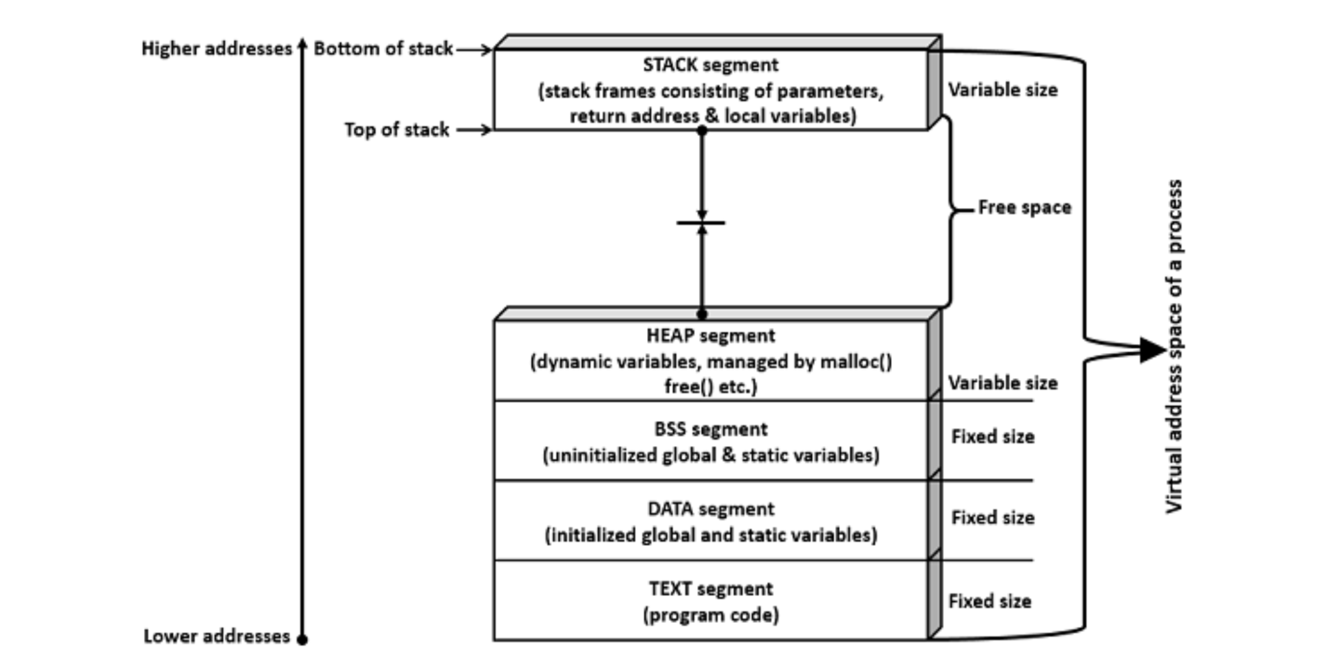

**Code segment** is a portion of object file or program’s virtual address space that consists of executable instructions. This is usually read-only data segment and has a fixed size.

Data segment is of two types.

* Initialized
* Un-initialized

**Initialized data segment** is a portion of the object file or program’s virtual address space that consists of initialized static and global variables.

**Un-initialized data segment** is a portion of the object file or program’s virtual address space that consists of uninitialized static and global variables. Un-initialized data segment is also called BSS (Block Started by Symbol) segment.

**Data segment** is read-write, since the values of variables could be changed during run time. This segment also has a fixed size.

**Stack segment** is an area of memory allotted for automatic variables and function parameters. It also stores a return address while executing function calls. Stack uses LIFO (Last-In-First-Out) mechanism for storing local or automatic variables, function parameters and storing next address or return address. The return address refers to the address to return after completion of function execution. This segment size is variable as per local variables, function parameters, and function calls. This segment grows from a higher address to a lower address.

**Heap segment** is area of memory allotted for dynamic memory storage such as for malloc() and calloc() calls. This segment size is also variable as per user allocation. This segment grows from a lower address to a higher address.

Let us now check how the segments (data and bss segments) size vary with a few sample programs. Segment size is known by executing the command “size”.

**System Calls: (Brief):**

a) fork() – child process creation.

b) wait() – makes the process to wait.

c) wait_id() – wait for a particular process

d) wait_pid() – wait for a particular process.

e) _exit – to terminate the process

f) getrlimit(), setrlimit(), prlimit(): System calls related to accessing and setting resource limits

|  |  |  |
| --- | --- | --- |
| Category | System Call | Description |
| General | open () | This system call either opens an already existing file or creates and opens a new file. |
| General | create () | Creates and opens a new file. |
| General | read () | Reads the contents of the file into the required buffer. |
| General | write () | Writes the contents of buffer into the file. |
| General | close () | Closes the file descriptor. |
| General | stat () | Provides information on the file. |
| Pipes | pipe () | Creates pipe for communication which returns two file descriptors for reading and writing.(b/w only related processes like b/w main and child) |
| Named Pipes or Fifo | mknod () | Creates a memory device file or special file to create FIFOs(2 unrelated processes but one way communication) |
| Named Pipes or Fifo | mkfifo () | Creates a new FIFO(two unrelated processes) |
| Shared Memory | shmget () | Creates a new shared memory segment or gets the identifier of the existing segment. |
| Shared Memory | shmat () | Attaches the shared memory segment and makes the segment a part of the virtual memory of the calling process. |
| Shared Memory | shmdt () | Detaches the shared memory segment. |
| Shared Memory | shmctl () | Performs control operations for the shared memory. Few of the generic control operations for the shared memory are removing the shared memory segment (IPC_RMID), receiving the information of the shared memory (IPC_STAT) and updating new values of the existing shared memory (IPC_SET). |
| Message Queues | msgget () | Creates a new message queue or accesses an already existing message queue and gets the handle or identifier to perform operations with regard to message queue, such as sending message/s to queue and receiving message/s from the queue. |
| Message Queues | msgsnd () | Sends a message to the required message queue with the required identification number. |
| Message Queues | msgrcv () | Receives a message from the message queue. By default, this is infinite wait operation, means the call will be blocked until it receives a message. |
| Message Queues | msgctl () | Performs control operations for the message queue. Few of the generic control operations for the message queue are removing the message queue (IPC_RMID), receiving the information of the message queue (IPC_STAT) and updating new values of the existing message queue (IPC_SET). |
| Semaphores | semget () | Creates a new semaphore or gets the identifier of the existing semaphore. Semaphores are used to perform synchronization between various IPCs working on the same object. |
| Semaphores | semop () | Performs semaphore operations on semaphore values. The basic semaphore operations are either acquiring or releasing the lock on the semaphore. |
| Semaphores | semctl () | Performs control operations for the semaphore. Few of the generic control operations for the semaphore are removing the semaphore (IPC_RMID), receiving the information of the semaphore (IPC_STAT) and updating new values of the existing semaphore (IPC_SET). |
| Signals | signal () | Setting the disposition of the signal (signal number) and the signal handler. In other terms, registering the routine, which gets executed when that signal is raised. |
| Signals | sigaction () | Same as signal(), setting the disposition of the signal i.e., performing certain action as per the registered signal handler after the receipt of the registered signal. This system call supports finer control over signal() such as blocking certain signals, restoring signal action to the default state after calling the signal handler, providing information such as consumed time of the user and the system, process id of sending process, etc. |
| Memory Mapping | mmap () | Mapping files into the memory. Once mapped into the memory, accessing files is as easy as accessing data using addresses and also in this way, the call is not expensive as system calls. |
| Memory Mapping | munmap () | Un-mapping the mapped files from the memory. |

**Process Creation:**

**FORK:**

Process creation is achieved through the **fork() system call**. The newly created process is called the child process and the process that initiated it (or the process when execution is started) is called the parent process. After the fork() system call, now we have two processes - parent and child processes. How to differentiate them? Very simple, it is through their return values.

Creates the child process. After this call, there are two processes, the existing one is called the parent process and the newly created one is called the child process.

The **fork() system call returns either** of the three values –

a) negative – creation of child process failed.

b) zero(0) – child process successfully created

c) Returns a positive value for the parent process. This value is the process ID of the newly created child process.

**Note:** − Usually after fork() call, the child process and the parent process would perform different tasks. If the same task needs to be run, **then for each fork() call it would run 2 power n times,** where **n** is the number of times fork() is invoked.

In the above case, fork() is called once, hence the output is printed twice (2 power 1). If fork() is called, say 3 times, then the output would be printed 8 times (2 power 3). If it is called 5 times, then it prints 32 times and so on and so forth.

Having seen fork() create the child process, it is time to see the details of the parent and the child processes.

A process can terminate in either of the two ways −

* Abnormally, occurs on delivery of certain signals, say terminate signal.
* Normally, using **_exit() system call** (or **_Exit() system call**) or **exit() library function.**

The difference between _exit() and exit() is mainly the cleanup activity. The **exit()** does some cleanup before returning the control back to the kernel, while the **_exit()** (or _Exit()) would return the control back to the kernel immediately.

As we have seen, whenever we create a child process from a program using fork, the following happens −

* Current process now becomes the parent process
* The new process becomes the child process

What happens if the parent process finishes its task early than the child process and then quits or exits? Now who would be the parent of the child process? The parent of the child process is init process, which is the very first process initiating all the tasks.

To monitor the child process execution state, to check whether the child process is running or stopped or to check the execution status, etc. the wait() system calls and its variants is used.

Let us consider an example program, where the parent process does not wait for the child process, which results into init process becoming the new parent for the child process.

**Note** − Even though child returns the exit status of 3, why the parent process sees that as 768. The status is stored in the higher order byte, so it is stored in hexadecimal format as 0X0300, which is 768 in decimal. Normal termination is as follows

|  |  |
| --- | --- |
| Higher Order Byte (Bits 8 to 15) | Lower Order Byte (Bits 0 to 7) |
| Exit status (0 to 255) | 0 |

The wait() system call has limitation such as it can only wait until the exit of the next child. If we need to wait for a specific child it is not possible using wait(), however, it is possible using waitpid() system call.

The waitpid() system call would wait for specified children to terminate and return its termination status in the buffer as explained below.

#include <sys/types.h>

#include <sys/wait.h>

pid_t waitpid(pid_t pid, int *status, int options);

The above call returns the process ID of the terminated child on success and -1 on failure. The waitpid() system call suspends the execution of the current process and waits indefinitely until the specified children (as per pid value) terminates. The termination status from the child is available in the status.

The value of pid can be either of the following −

* **< -1** − Wait for any child process whose process group ID is equal to the absolute value of pid.
* **-1** − Wait for any child process, which equals to that of wait() system call.
* **0** − Wait for any child process whose process group ID is equal to that of the calling process.
* **>0** − Wait for any child process whose process ID is equal to the value of pid.

By default, waitpid() system call waits only for the terminated children but this default behavior can be modified using the options argument.

Now let us consider a program as an example, waiting for a specific process with its process id.

Now, let us check for waitid() system call. This system call waits for the child process to change state.

#include <sys/wait.h>

int waitid(idtype_t idtype, id_t id, siginfo_t *infop, int options);

The above system call waits for the child process to change the state and this call suspends the current/calling process until any of its child process changes its state. The argument ‘infop’ is to record the current state of the child. This call returns immediately, if the process has already changed its state.

The value of idtype can be either of the following −

* **P_PID** − Wait for any child process whose process ID is equal to that of id.
* **P_PGID** − Wait for any child process, whose process group ID is equal to that of id.
* **P_ALL** − Wait for any child process and id is ignored.
* The options argument is to specify which state changes and this can be formed with bitwise OR operation with the below-mentioned flags −
* **WCONTINUED** − Returns the status of any child that was stopped and has been continued.
* **WEXITED** − Waits for the process to exit.
* **WNOHANG** − Returns immediately.
* **WSTOPPED** − Waits for the process of any child that has stopped, upon receipt of the signal and returns the status.

This call returns 0, if it returns due to a change of the state of one of its children and WNOHANG is used. It returns –1, in case of error and sets the appropriate error number.

#include<stdio.h>

#include<unistd.h>

#include<sys/types.h>

#include<sys/wait.h>

int main() {

int pid;

int pids[3];

int status;

int numprocesses = 0;

int total_processes = 3;

siginfo_t siginfo;

while (numprocesses < total_processes) {

pid = fork();

// Child process

if (pid == 0) {

printf("In child process: process id is %d\n", getpid());

sleep(5);

return 2;

} else {

pids[numprocesses] = pid;

numprocesses++;

printf("In parent process: created process number: %d\n", pid);

}

}

// Waiting for 3rd child process

status = waitid(P_PID, pids[total_processes - 1], &siginfo, WEXITED);

if (status == -1) {

perror("waitid error");

return 1;

}

printf("Info received from waitid is: ");

printf("PID of child: %d, real user id of child: %d\n", siginfo.si_pid, siginfo.si_uid);

return 0;

}

**Other Processes:**

a) **Orphan Process**: When we create a process using fork(), the newly created process is the child process and the process that created the child is the parent process. In turn, the parent process of this is shell. Of course, the parent of all the processes is init process (Process ID → 1).

The above is a usual scenario, however, what happens if the parent process exits before the child process. The result is, the child process now becomes the orphan process. Then what about its parent, its new parent is the parent of all the processes, which is nothing but init process (Process ID – 1).

b) **Zombie Process**:

In simple terms, assume that you have two processes, namely the parent and the child process. It is the responsibility of the parent process to wait for child process and then clean up the child process entry from the process table. What if the parent process is not ready to wait for the child process, and in the meantime the child process gets its job done and exits? Now, the child process would become the zombie process. Of course, the zombie process is cleaned up after the parent process becomes ready.

**c) Daemon Process:**

In simple terms, the process which doesn’t have any associated shell or terminal is known as the daemon process. Why this is needed? These are the processes which run in the background to perform actions at predefined intervals and also respond to certain events. The daemon process should not have any user interaction, since it runs as a background process.

The internal Linux daemon processes usually ends with the letter “d” such as Kernel Daemons (ksoftirqd, kblockd, kswapd, etc.), Printing Daemons (cupsd, lpd, etc.), File Service Daemons (smbd, nmbd, etc.), Administrative database daemons (ypbind, ypserv, etc.), Electronic Mail Daemons (sendmail, popd, smtpd, etc.), Remote Login and Command Execution Daemons (sshd, in.telnetd, etc.), Booting and Configuration Daemons (dhcpd, udevd, etc.), init process (init), cron daemon, atd daemon, etc.

Now let us see how to create a daemon process. Following are the steps −

**Step 1** − Create a child process. Now we have two processes – the parent process and the child process

Usually the process hierarchy is SHELL → PARENT PROCESS → CHILD PROCESS

**Step 2** − Terminate the parent process by exiting. The child process now becomes the orphan process and is taken over by init process.

Now, the hierarchy is INIT PROCESS → CHILD PROCESS

**Step 3** − Calling the setsid() system call creates a new session, if the calling process is not a process group leader. Now the calling process becomes the group leader of the new session. This process will be the only process in this new process group and in this new session.

**Step 4** − Set the process group ID and session ID to PID of the calling process.

**Step 5** − Close the default file descriptors (standard input, standard output, and standard error) of the process as the terminal and shell are now disconnected from the application.

The process needs certain resources such as CPU and memory to perform the tasks.

**TOP Command:**

The top command continuously displays the usage of system resources. If any process puts the system in some kind of hang state (consuming more of CPU or Memory) it is possible to note the process information and take appropriate action (such as killing the related process).

**VMSTAT:**

The vmstat command reports the statistics of virtual memory subsystem. It reports the information of processes (waiting to run, sleeping, runnable processes, etc.), memory (virtual memory information such as free, used, etc.), swap area, IO devices, system information (number of interrupts, context switches) and CPU (user, system and idle time).

**Lsof:**

The lsof command prints the list of open files of all the current running processes, including system processes.

**Getconf: (**getconf –a):

The getconf command displays the system configuration variables information.

Now, let us take a look at the related system calls.

* System call getrusage(), which provides information on system resource usage.
* System calls related to accessing and setting resource limits viz., getrlimit(), setrlimit(), prlimit().

## System Resource Usage Call

#include <sys/time.h>

#include <sys/resource.h>

int getrusage(int who, struct rusage *usage);

The system call getrusage() returns the information on the system resource usage. This can include information on self, children, or calling thread using flags RUSAGE_SELF, RUSAGE_CHILDREN, RUSAGE_THREAD for the “who” variable. After the call, it returns the information in the structure rusage.

This call would return “0” on success and “-1” on failure.

**Pipes:**

Pipes were meant for communication between related processes. These cannot be used for communication b/w the unrelated processes.

We used one pipe for one-way communication and two pipes for bi-directional communication

**Named Pipes:** These are used for communication b/w the unrelated processes.

A single named pipe that can be used for two-way communication (communication between the server and the client, plus the client and the server at the same time) as Named Pipe supports bi-directional communication.

Another name for named pipe is **FIFO (First-In-First-Out)**. Let us see the system call (**mknod())** to create a named pipe, which is a kind of a special file.

#include <sys/types.h>

#include <sys/stat.h>

#include <fcntl.h>

#include <unistd.h>

int mknod(const char *pathname, mode_t mode, dev_t dev);

This system call would create a special file or file system node such as ordinary file, device file, or FIFO. The arguments to the system call are pathname, mode and dev. The pathname along with the attributes of mode and device information. The pathname is relative, if the directory is not specified it would be created in the current directory. The mode specified is the mode of file which specifies the file type such as the type of file and the file mode as mentioned in the following tables. The dev field is to specify device information such as major and minor device numbers.

This library function creates a FIFO special file, which is used for named pipe. The arguments to this function is file name and mode. The file name can be either absolute path or relative path. If full path name (or absolute path) is not given, the file would be created in the current folder of the executing process. The file mode information is as described in mknod() system call.

This call would return zero on success and -1 in case of failure. To know the cause of failure, check with errno variable or perror() function.

Let us consider a program of running the server on one terminal and running the client on another terminal. The program would only perform one-way communication. The client accepts the user input and sends the message to the server, the server prints the message on the output. The process is continued until the user enters the string “end”.

Let us understand this with an example −

**Step 1** − Create two processes, one is fifoserver and another one is fifoclient.

**Step 2** − Server process performs the following −

* Creates a named pipe (using system call mknod()) with name “MYFIFO”, if not created.
* Opens the named pipe for read only purposes.
* Here, created FIFO with permissions of read and write for Owner. Read for Group and no permissions for Others.
* Waits infinitely for message from the Client.
* If the message received from the client is not “end”, prints the message. If the message is “end”, closes the fifo and ends the process.

**Step 3** − Client process performs the following −

* Opens the named pipe for write only purposes.
* Accepts the string from the user.
* Checks, if the user enters “end” or other than “end”. Either way, it sends a message to the server. However, if the string is “end”, this closes the FIFO and also ends the process.
* Repeats infinitely until the user enters string “end”.

Let us take a look at the bi-directional communication i.e., the client sending message to the server and the server receiving the message and sending back another message to the client using the same named pipe.

Step 1 − Create two processes, one is fifoserver_twoway and another one is fifoclient_twoway.

Step 2 − Server process performs the following −

* Creates a named pipe (using library function mkfifo()) with name “fifo_twoway” in /tmp directory, if not created.
* Opens the named pipe for read and write purposes.
* Here, created FIFO with permissions of read and write for Owner. Read for Group and no permissions for Others.
* Waits infinitely for a message from the client.
* If the message received from the client is not “end”, prints the message and reverses the string. The reversed string is sent back to the client. If the message is “end”, closes the fifo and ends the process.

Step 3 − Client process performs the following −

* Opens the named pipe for read and write purposes.
* Accepts string from the user.
* Checks, if the user enters “end” or other than “end”. Either way, it sends a message to the server. However, if the string is “end”, this closes the FIFO and also ends the process.
* If the message is sent as not “end”, it waits for the message (reversed string) from the client and prints the reversed string.
* Repeats infinitely until the user enters the string “end”.

**Usually, inter-related process communication is performed using Pipes or Named Pipes. Unrelated processes (say one process running in one terminal and another process in another terminal) communication can be performed using Named Pipes or through popular IPC techniques of Shared Memory and Message Queues.**

**Shared Memory:**

We know that to communicate between two or more processes, we use shared memory but before using the shared memory what needs to be done with the system calls, let us see this −

* Create the shared memory segment or use an already created shared memory segment (shmget())
* Attach the process to the already created shared memory segment (shmat())
* Detach the process from the already attached shared memory segment (shmdt())
* Control operations on the shared memory segment (shmctl())
* int shmget(key_t key, size_t size, int shmflg)
* This call would return a valid shared memory identifier (used for further calls of shared memory) on success and -1 in case of failure. To know the cause of failure, check with errno variable or perror() function.

The first argument, key, recognizes the shared memory segment. The key can be either an arbitrary value or one that can be derived from the library function ftok(). The key can also be IPC_PRIVATE, means, running processes as server and client (parent and child relationship) i.e., inter-related process communiation. If the client wants to use shared memory with this key, then it must be a child process of the server. Also, the child process needs to be created after the parent has obtained a shared memory.

The second argument, size, is the size of the shared memory segment rounded to multiple of PAGE_SIZE.

The third argument, shmflg, specifies the required shared memory flag/s such as IPC_CREAT (creating new segment) or IPC_EXCL (Used with IPC_CREAT to create new segment and the call fails, if the segment already exists). Need to pass the permissions as well.

void * shmat(int shmid, const void *shmaddr, int shmflg)

The above system call performs shared memory operation for System V shared memory segment i.e., attaching a shared memory segment to the address space of the calling process. The arguments that need to be passed are as follows −

The first argument, shmid, is the identifier of the shared memory segment. This id is the shared memory identifier, which is the return value of shmget() system call.

The second argument, shmaddr, is to specify the attaching address. If shmaddr is NULL, the system by default chooses the suitable address to attach the segment. If shmaddr is not NULL and SHM_RND is specified in shmflg, the attach is equal to the address of the nearest multiple of SHMLBA (Lower Boundary Address). Otherwise, shmaddr must be a page aligned address at which the shared memory attachment occurs/starts.

The third argument, shmflg, specifies the required shared memory flag/s such as SHM_RND (rounding off address to SHMLBA) or SHM_EXEC (allows the contents of segment to be executed) or SHM_RDONLY (attaches the segment for read-only purpose, by default it is read-write) or SHM_REMAP (replaces the existing mapping in the range specified by shmaddr and continuing till the end of segment).

int shmctl(int shmid, int cmd, struct shmid_ds *buf)

The above system call performs control operation for a System V shared memory segment. The following arguments needs to be passed −

The first argument, shmid, is the identifier of the shared memory segment. This id is the shared memory identifier, which is the return value of shmget() system call.

The second argument, cmd, is the command to perform the required control operation on the shared memory segment.

Valid values for cmd are −

* **IPC_STAT** − Copies the information of the current values of each member of struct shmid_ds to the passed structure pointed by buf. This command requires read permission to the shared memory segment.
* **IPC_SET** − Sets the user ID, group ID of the owner, permissions, etc. pointed to by structure buf.
* **IPC_RMID** − Marks the segment to be destroyed. The segment is destroyed only after the last process has detached it.
* **IPC_INFO** − Returns the information about the shared memory limits and parameters in the structure pointed by buf.
* **SHM_INFO** − Returns a shm_info structure containing information about the consumed system resources by the shared memory.

The third argument, buf, is a pointer to the shared memory structure named struct shmid_ds. The values of this structure would be used for either set or get as per cmd.

This call returns the value depending upon the passed command. Upon success of IPC_INFO and SHM_INFO or SHM_STAT returns the index or identifier of the shared memory segment or 0 for other operations and -1 in case of failure. To know the cause of failure, check with errno variable or perror() function.

Let us consider the following sample program.

* Create two processes, one is for writing into the shared memory (shm_write.c) and another is for reading from the shared memory (shm_read.c)
* The program performs writing into the shared memory by write process (shm_write.c) and reading from the shared memory by reading process (shm_read.c)
* In the shared memory, the writing process, creates a shared memory of size 1K (and flags) and attaches the shared memory
* The write process writes 5 times the Alphabets from ‘A’ to ‘E’ each of 1023 bytes into the shared memory. Last byte signifies the end of buffer
* Read process would read from the shared memory and write to the standard output
* Reading and writing process actions are performed simultaneously
* After completion of writing, the write process updates to indicate completion of writing into the shared memory (with complete variable in struct shmseg)
* Reading process performs reading from the shared memory and displays on the output until it gets indication of write process completion (complete variable in struct shmseg)
* Performs reading and writing process for a few times for simplication and also in order to avoid infinite loops and complicating the program.

Why do we need message queues when we already have the shared memory? It would be for multiple reasons, let us try to break this into multiple points for simplification −

* As understood, once the message is received by a process it would be no longer available for any other process. Whereas in shared memory, the data is available for multiple processes to access.
* If we want to communicate with small message formats.
* Shared memory data need to be protected with synchronization when multiple processes communicating at the same time.
* Frequency of writing and reading using the shared memory is high, then it would be very complex to implement the functionality. Not worth with regard to utilization in this kind of cases.
* What if all the processes do not need to access the shared memory but very few processes only need it, it would be better to implement with message queues.
* If we want to communicate with different data packets, say process A is sending message type 1 to process B, message type 10 to process C, and message type 20 to process D. In this case, it is simplier to implement with message queues. To simplify the given message type as 1, 10, 20, it can be either 0 or +ve or –ve as discussed below.
* Ofcourse, the order of message queue is FIFO (First In First Out). The first message inserted in the queue is the first one to be retrieved.

Using Shared Memory or Message Queues depends on the need of the application and how effectively it can be utilized.

Communication using message queues can happen in the following ways −

* Writing into the shared memory by one process and reading from the shared memory by another process. As we are aware, reading can be done with multiple processes as well.

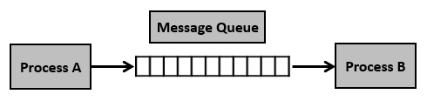

* Writing into the shared memory by one process with different data packets and reading from it by multiple processes, i.e., as per message type.

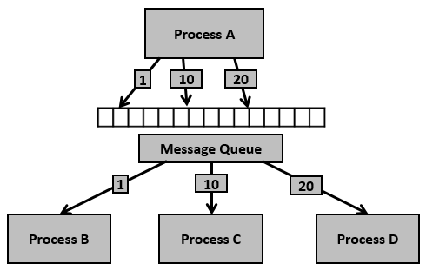

Having seen certain information on message queues, now it is time to check for the system call (System V) which supports the message queues.

To perform communication using message queues, following are the steps −

**Step 1** − Create a message queue or connect to an already existing message queue (msgget())

**Step 2** − Write into message queue (msgsnd())

**Step 3** − Read from the message queue (msgrcv())

**Step 4** − Perform control operations on the message queue (msgctl())

Now, let us check the syntax and certain information on the above calls.

#include <sys/types.h>

#include <sys/ipc.h>

#include <sys/msg.h>

int msgget(key_t key, int msgflg)

This system call creates or allocates a System V message queue. Following arguments need to be passed −

* The first argument, key, recognizes the message queue. The key can be either an arbitrary value or one that can be derived from the library function ftok().
* The second argument, shmflg, specifies the required message queue flag/s such as IPC_CREAT (creating message queue if not exists) or IPC_EXCL (Used with IPC_CREAT to create the message queue and the call fails, if the message queue already exists). Need to pass the permissions as well.

**Note** − Refer earlier sections for details on permissions.

This call would return a valid message queue identifier (used for further calls of message queue) on success and -1 in case of failure. To know the cause of failure, check with errno variable or perror() function.

Various errors with respect to this call are EACCESS (permission denied), EEXIST (queue already exists can’t create), ENOENT (queue doesn’t exist), ENOMEM (not enough memory to create the queue), etc.

#include <sys/types.h>

#include <sys/ipc.h>

#include <sys/msg.h>

int msgsnd(int msgid, const void *msgp, size_t msgsz, int msgflg)

This system call sends/appends a message into the message queue (System V). Following arguments need to be passed −

* The first argument, msgid, recognizes the message queue i.e., message queue identifier. The identifier value is received upon the success of msgget()
* The second argument, msgp, is the pointer to the message, sent to the caller, defined in the structure of the following form −

struct msgbuf {

long mtype;

char mtext[1];

};

The variable mtype is used for communicating with different message types, explained in detail in msgrcv() call. The variable mtext is an array or other structure whose size is specified by msgsz (positive value). If the mtext field is not mentioned, then it is considered as zero size message, which is permitted.

* The third argument, msgsz, is the size of message (the message should end with a null character)
* The fourth argument, msgflg, indicates certain flags such as IPC_NOWAIT (returns immediately when no message is found in queue or MSG_NOERROR (truncates message text, if more than msgsz bytes)

This call would return 0 on success and -1 in case of failure. To know the cause of failure, check with errno variable or perror() function.

#include <sys/types.h>

#include <sys/ipc.h>

#include <sys/msg.h>

int msgrcv(int msgid, const void *msgp, size_t msgsz, long msgtype, int msgflg)

This system call retrieves the message from the message queue (System V). Following arguments need to be passed −

* The first argument, msgid, recognizes the message queue i.e., the message queue identifier. The identifier value is received upon the success of msgget()
* The second argument, msgp, is the pointer of the message received from the caller. It is defined in the structure of the following form −

struct msgbuf {

long mtype;

char mtext[1];

};

The variable mtype is used for communicating with different message types. The variable mtext is an array or other structure whose size is specified by msgsz (positive value). If the mtext field is not mentioned, then it is considered as zero size message, which is permitted.

* The third argument, msgsz, is the size of the message received (message should end with a null character)
* The fouth argument, msgtype, indicates the type of message −
  + **If msgtype is 0** − Reads the first received message in the queue
  + **If msgtype is +ve** − Reads the first message in the queue of type msgtype (if msgtype is 10, then reads only the first message of type 10 even though other types may be in the queue at the beginning)
  + **If msgtype is –ve** − Reads the first message of lowest type less than or equal to the absolute value of message type (say, if msgtype is -5, then it reads first message of type less than 5 i.e., message type from 1 to 5)
* The fifth argument, msgflg, indicates certain flags such as IPC_NOWAIT (returns immediately when no message is found in the queue or MSG_NOERROR (truncates the message text if more than msgsz bytes)

This call would return the number of bytes actually received in mtext array on success and -1 in case of failure. To know the cause of failure, check with errno variable or perror() function.

#include <sys/types.h>

#include <sys/ipc.h>

#include <sys/msg.h>

int msgctl(int msgid, int cmd, struct msqid_ds *buf)

This system call performs control operations of the message queue (System V). Following arguments need to be passed −

* The first argument, msgid, recognizes the message queue i.e., the message queue identifier. The identifier value is received upon the success of msgget()
* The second argument, cmd, is the command to perform the required control operation on the message queue. Valid values for cmd are −

**IPC_STAT** − Copies information of the current values of each member of struct msqid_ds to the passed structure pointed by buf. This command requires read permission on the message queue.

**IPC_SET** − Sets the user ID, group ID of the owner, permissions etc pointed to by structure buf.

**IPC_RMID** − Removes the message queue immediately.

**IPC_INFO** − Returns information about the message queue limits and parameters in the structure pointed by buf, which is of type struct msginfo

**MSG_INFO** − Returns an msginfo structure containing information about the consumed system resources by the message queue.

* The third argument, buf, is a pointer to the message queue structure named struct msqid_ds. The values of this structure would be used for either set or get as per cmd.

This call would return the value depending on the passed command. Success of IPC_INFO and MSG_INFO or MSG_STAT returns the index or identifier of the message queue or 0 for other operations and -1 in case of failure. To know the cause of failure, check with errno variable or perror() function.

Having seen the basic information and system calls with regard to message queues, now it is time to check with a program.

Let us see the description before looking at the program −

**Step 1** − Create two processes, one is for sending into message queue (msgq_send.c) and another is for retrieving from the message queue (msgq_recv.c)

**Step 2** − Creating the key, using ftok() function. For this, initially file msgq.txt is created to get a unique key.

**Step 3** − The sending process performs the following.

* Reads the string input from the user
* Removes the new line, if it exists
* Sends into message queue
* Repeats the process until the end of input (CTRL + D)
* Once the end of input is received, sends the message “end” to signify the end of the process

**Step 4** − In the receiving process, performs the following.

* Reads the message from the queue
* Displays the output
* If the received message is “end”, finishes the process and exits

To simplify, we are not using the message type for this sample. Also, one process is writing into the queue and another process is reading from the queue. This can be extended as needed i.e., ideally one process would write into the queue and multiple processes read from the queue.

Now, let us check the process (message sending into queue) – File: msgq_send.c

/* Filename: msgq_send.c */

#include <stdio.h>

#include <string.h>

#include <stdlib.h>

#include <errno.h>

#include <string.h>

#include <sys/types.h>

#include <sys/ipc.h>

#include <sys/msg.h>

#define PERMS 0644

struct my_msgbuf {

long mtype;

char mtext[200];

};

int main(void) {

struct my_msgbuf buf;

int msqid;

int len;

key_t key;

system("touch msgq.txt");

if ((key = ftok("msgq.txt", 'B')) == -1) {

perror("ftok");

exit(1);

}

if ((msqid = msgget(key, PERMS | IPC_CREAT)) == -1) {

perror("msgget");

exit(1);

}

printf("message queue: ready to send messages.\n");

printf("Enter lines of text, ^D to quit:\n");

buf.mtype = 1; /* we don't really care in this case */

while(fgets(buf.mtext, sizeof buf.mtext, stdin) != NULL) {

len = strlen(buf.mtext);

/* remove newline at end, if it exists */

if (buf.mtext[len-1] == '\n') buf.mtext[len-1] = '\0';

if (msgsnd(msqid, &buf, len+1, 0) == -1) /* +1 for '\0' */

perror("msgsnd");

}

strcpy(buf.mtext, "end");

len = strlen(buf.mtext);

if (msgsnd(msqid, &buf, len+1, 0) == -1) /* +1 for '\0' */

perror("msgsnd");

if (msgctl(msqid, IPC_RMID, NULL) == -1) {

perror("msgctl");

exit(1);

}

printf("message queue: done sending messages.\n");

return 0;

}

## **Compilation and Execution Steps**

message queue: ready to send messages.

Enter lines of text, ^D to quit:

this is line 1

this is line 2

message queue: done sending messages.

Following is the code from message receiving process (retrieving message from queue) – File: msgq_recv.c

/* Filename: msgq_recv.c */

#include <stdio.h>

#include <stdlib.h>

#include <errno.h>

#include <sys/types.h>

#include <sys/ipc.h>

#include <sys/msg.h>

#define PERMS 0644

struct my_msgbuf {

long mtype;

char mtext[200];

};

int main(void) {

struct my_msgbuf buf;

int msqid;

int toend;

key_t key;

if ((key = ftok("msgq.txt", 'B')) == -1) {

perror("ftok");

exit(1);

}

if ((msqid = msgget(key, PERMS)) == -1) { /* connect to the queue */

perror("msgget");

exit(1);

}

printf("message queue: ready to receive messages.\n");

for(;;) { /* normally receiving never ends but just to make conclusion

/* this program ends wuth string of end */

if (msgrcv(msqid, &buf, sizeof(buf.mtext), 0, 0) == -1) {

perror("msgrcv");

exit(1);

}

printf("recvd: \"%s\"\n", buf.mtext);

toend = strcmp(buf.mtext,"end");

if (toend == 0)

break;

}

printf("message queue: done receiving messages.\n");

system("rm msgq.txt");

return 0;

}

## **Compilation and Execution Steps**

message queue: ready to receive messages.

recvd: "this is line 1"

recvd: "this is line 2"

recvd: "end"

message queue: done receiving messages.

**Signals are generated by the system:**

Signals can be:

The actions performed for the signals are as follows:

a) Default action.

b) Handle signal.

c) Ignore the signal

The system call signal() would call the registered handler upon generation of signal as mentioned in signum. The handler can be either one of the SIG_IGN (Ignoring the Signal), SIG_DFL (Setting signal back to default mechanism) or user-defined signal handler or function address.

#include <signal.h>

typedef void (*sighandler_t) (int);

sighandler_t signal(int signum, sighandler_t handler);

This system call on success returns the address of a function that takes an integer argument and has no return value. This call returns SIG_ERR in case of error.

Though with signal() the respective signal handler as registered by the user can be called, fine tuning such as masking the signals that should be blocked, modifying the behavior of a signal, and other functionalities are not possible. This are possible using sigaction() system call.

#include <signal.h>

s

int sigaction(int signum, const struct sigaction *act, struct sigaction *oldact)

## **mutable Keyword**

mutable keyword is used with member variables of class, which we want to change even if the object is of const type. Hence, mutable data members of a const objects can be modified.

**Valgrind:**

a) usage: valgrind –tool=<tooltype> ./binary

**Types of tools used:**

a) Memcheck: used to find out memory management problems

a) uninitialized memory.

b) Unfreed memory(memory leaks).

c) Does bad frees of heap blocks (double frees, mismatched frees).

* d) Passes overlapping source and destination memory blocks to memcpy() and related functions.
* Memcheck reports these errors as soon as they occur, giving the source line number at which it occurred, and also a stack trace of the functions called to reach that line. Memcheck tracks addressability at the byte-level, and initialisation of values at the bit-level. As a result, it can detect the use of single uninitialised bits, and does not report spurious errors on bitfield operations. Memcheck runs programs about 10--30x slower than normal.

**b) Massif:** Massif is a heap profiler. It performs detailed heap profiling by taking regular snapshots of a program's heap. It produces a graph showing heap usage over time, including information about which parts of the program are responsible for the most memory allocations. The graph is supplemented by a text or HTML file that includes more information for determining where the most memory is being allocated. Massif runs programs about 20x slower than normal.

**c) Helgrind**: Helgrind is a thread debugger which finds data races in multithreaded programs. It looks for memory locations which are accessed by more than one (POSIX p-)thread, but for which no consistently used (pthread_mutex_) lock can be found. Such locations are indicative of missing synchronisation between threads, and could cause hard-to-find timing-dependent problems. It is useful for any program that uses pthreads. It is a somewhat experimental tool, so your feedback is especially welcome here.

### d) Lackey, Nulgrind

Lackey and Nulgrind are also included in the Valgrind distribution. They don't do very much, and are there for testing and demonstrative purposes.

### Cachegrind

Cachegrind is a cache profiler. It performs detailed simulation of the I1, D1 and L2 caches in your CPU and so can accurately pinpoint the sources of cache misses in your code. It identifies the number of cache misses, memory references and instructions executed for each line of source code, with per-function, per-module and whole-program summaries. It is useful with programs written in any language. Cachegrind runs programs about 20--100x slower than normal.

### Callgrind

Callgrind, by Josef Weidendorfer, is an extension to [Cachegrind](https://www.valgrind.org/info/tools.html" \l "cachegrind). It provides all the information that Cachegrind does, plus extra information about callgraphs. It was folded into the main Valgrind distribution in version 3.2.0. Available separately is an amazing visualisation tool, [KCachegrind](http://kcachegrind.sourceforge.net/cgi-bin/show.cgi/KcacheGrindIndex), which gives a much better overview of the data that Callgrind collects; it can also be used to visualise Cachegrind's output.

### DHAT

DHAT is a tool for examining how programs use their heap allocations. It tracks the allocated blocks, and inspects every memory access to find which block, if any, it is to. It comes with a GUI to facilitate exploring the profile results.

### Experimental Tools

#### BBV

A basic block is a linear section of code with one entry point and one exit point. A basic block vector (BBV) is a list of all basic blocks entered during program execution, and a count of how many times each basic block was run.

BBV is a tool that generates basic block vectors for use with the SimPoint analysis tool.

#### SGCheck

SGCheck is a tool for finding overruns of stack and global arrays. It works by using a heuristic approach derived from an observation about the likely forms of stack and global array accesses.

### Link the object code using the -fPIC and -shared options

The default behaviour of the gcc and g++ commands when linking is to produce an executable program. They can be instructed to produce a shared library instead by means of -shared option:

**gcc -shared -fPIC -Wl,-soname,libqux.so.1 -o libqux.so.1.5.0 foo.o bar.o baz.o -lc**

The -fPIC option is needed when linking as it was when compiling to ensure that any code added by the linker is compatible with code previously generated by the compiler.

The -Wl option passes a comma-separated list of arguments to the linker. As its name suggests, -soname specifies the required soname. If these options are omitted then the library will not have an soname.

The ldconfig manpage recommends explicitly linking against libc, which has been done above using the -l option (-lc).

Signal overview

Signals are most simplest way to notify a process with an information code. This code number is signal number. Each signal has different meaning and there are default action defined for each signals. Default action for every signal is to terminate the process. Signal is a type of interprocess communication. These can come from operation system kernel to notify process has one or more critical errors. This is used by shell to inform a process to take some actions or these can be sent by process itself.

Signal Handler

Applications often execute valuable section and any type of interruptions are not desirable. It is possible that user can interrupt a process with Ctrl+C which sends SIGINT and Ctrl+Break which sends SIGBRK. Programmer installs a signal handler and prints a warning message and this prevents unexpected exit. Alternatively programmer can set handler as SIG_IGN for those signals which programmer wants to ignore.

Function prototypes

void signal(int, void (__cdecl *)(int));

int raise(int);

Signal types

* SIGINT - Interrupt signal received by shell or user(Ctrl+C)*
* SIGILL - Illegal instruction executed by CPU and task scheduler sets this signal
* SIGFPE - Encountered floating point exception in FPU and
* SIGSEGV - segment violation
* SIGTERM - Software termination signal from kill
* SIGBREAK - Break signal received by shell or user (Ctrl-Break)
* SIGABRT - Abnormal termination triggered by abort call

Defined signal action codes

* SIG_DFL(0) - default signal action
* SIG_IGN(1) - ignore signal
* SIG_SGE(3) - signal gets error
* SIG_ACK(4) - acknowledge

Signal

signal() is the C library routine to install signal handler for a particulate signal. First argument is the signal code and next is the function pointer of the user handler. User has options to install user defined handler or handler to ignore the signal or revert original signal to default action.

**Raise/Kill**

raise() is a library function to send a signal code to its own. It takes signal code as argument and sends the signal to the same process id. C library does not have any function to send a signal to other process. Kill is a system to send a signal to a specific process id.

**Bridge Design Pattern:** Connecting components together with through abstractions

Bridge prevents a ‘Cartesian Product’ complexity Explosion.

Example:

a) Base class thread scheduler.

b) Can be preemptive or cooperative

c) Can run on Windows or Unix

d) End up with with a 2*2 scenario: WindowsPTS, UnixPTS, WindowsCTS, UnixCTS.

Note: Bridge Pattern avoids the entity explosion.

**Note:** A mechanism that decouples an interface(hierarchy) from an implementation(hierarchy).

**Rabbitmq LINK:**

[**https://pulse.mozilla.org/api/**](https://pulse.mozilla.org/api/)

**IPC:**

a) What is IPC?

b) Various ways to implement IPC on Linux:

a) Unix Domain Sockets (i.e Socket based communication)

b) Message Queues

c) Shared Memory

d) Signals

c) Design discussion on IPC

d) Project on IPC

**Application Layer**

**Kernel(Operation System)**

**DeviceDrivers**

**HardWare(RAM,CPU,DISK)**

**Note:** IPC is basically the communication b/w the processes which are running on the **same** machine.

**Note:There is a different way for processes to communicate which are running on different machines i.e “Using Network Sockets (Not covered in this course)**

**Sockets:**

a) Unix/Linux OS provide **Socket Interface** to carryout communication b/w various types of entities.

b) The Socket Interface are a bunch of Socket Programming related APIs

c) 2 Types of sockets can be implemented using above interface:

i) Unix Domain Sockets (IPC b/w processes running on the same system)

ii) Network Sockets (Communication b/w the processes running on different physical machines)

d) **System Calls:** socket(), accept(), connect(), sendto(),rcvfrom(),close()

**Socket Message Types:**

a) Messages exchanged b/w the client and server processes can be categorized into 2 types:

i) **Connection Initiation request messages**: This msg is used by the client process to request the server process to establish **a dedicated** connection.

ii) only after the connection has been established, then only client can send “Service Request Messages”

iii) **Service Request Messages:** Client can send msg to server once the connection is fully established.

Through these messages, Client request server to provide a service.

b) Server Identifies and process both the types of messages very differently.

**State Machine of Client Server Communication:**

Master File Description

connection request

Cr

e

te

Cr

e

tee

Client2

**Client1**

a) **Socket Master File Description:** When the server boots up, it creates a new connection socket (also called “Master socket file descriptor” using socket())

b) M is mother of all **client handles.** M gives birth to all Client handles are also called as “**data sockets”**

c) Once the client handles are created for each client by Master File Descriptor, server carries out communication (actual data exchange) with client using Client Handle(are not M).

d) Server has to maintain the database of connected client handles or data sockets.

e) M is used to create only new client handles but not for data exchanges.

f) **accept() is the system call** used on Server side to create new client handles.

g) In Linux terminology, handles are called as “File Descriptors” which are just +ve numbers.

Client Handles are called “Communication File descriptors” Or “Data Sockets”

and M is called as “Master Socket File descriptor” Or “Connection Socket”

**UNIX Domain Sockets:**

a) Unix domain sockets are used for carrying out IPC b/w 2 processes running on SAME machine.

b) using Unix domain sockets, we can setup either STREAM or DATA STREAM based communication.

i) STREAM(TCP) : When large file need to be moved or copied form one location to other location e.g copying a movie, continuous flow of bytes, like water flow.

ii) DATAGRAM(UDP): When small units of data needs to be moved from one process to another within a system.

Ex:

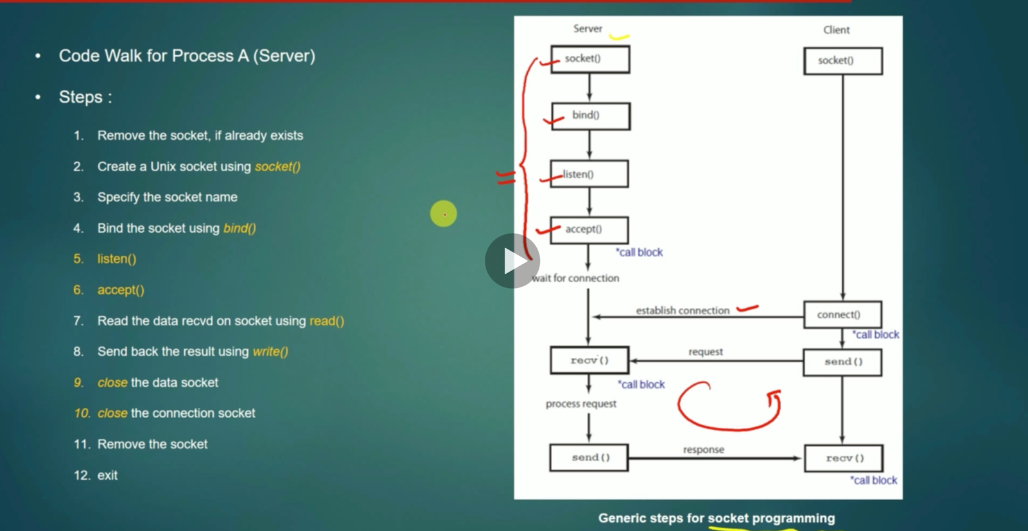

High Level Sock Desing information:

|  |  |  |  |
| --- | --- | --- | --- |
|  | Client Side API(system calls) | Server Side API(system calls) |  |
|  | connect() | accept (blocking call) |  |
|  | write()-----------------🡪  sendto()----------🡪  sendmsg()------🡪 | read()  recvfrom() (blocking system calls)  recvfrom() |  |

A Server can be redesigned to serve multiple clients at the same time using the **concept of multiplexing.**

**MULTIPLEXING:**

a) Multiplexing is a mechanism through which server process can monitor multiple clients at the same time.

b) Without multiplexing, server process can entertain only one client at a time, and cannot entertain other client’s requests until it finishes with the current client.

**select() system call:**  Monitor all Clients activity at the same time.

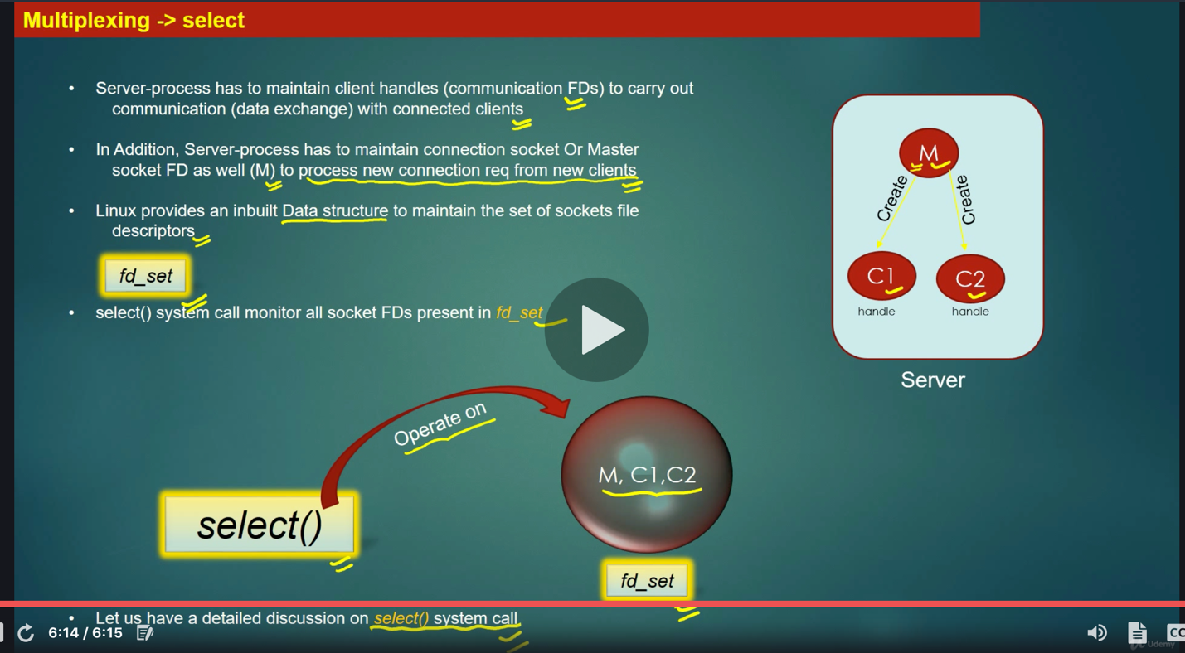

a) select() system call allows the SERVER machine to MONITOR existing clients(client socket file descriptors) already connected and check which client has send the data to process.

b) select() system call is a blocking system call, meaning when it executes, code execution halts.

c) select() unblocks when either fo the 2 things happen on server side:

i) New connection request from the client arrives.

ii) Data request from existing connected client arrives.

d) When select() unblocks, server needs to check whether it’s a new connection request or new Data request on existing code , in later case, server needs to find which client had send the data.

e) When Server starts, ti creates a MASTER Socket – A socket to detect arrival of new connection request from new client.

f) This master socket, Once created, gives birth to rest of the communication file socket descriptors for Clients,

g) C Provides a **Data Structure called “fd_set”** which is a collection of (or a set) of file descriptors.

**fd_set DATA STRUCTURE:** fd_set is a collection of file descriptors.

fd_set readfds;

**MULTIPLEXING STATE MACHINE:**  Here how select() and accept() system calls work together to create a multiplexing server.

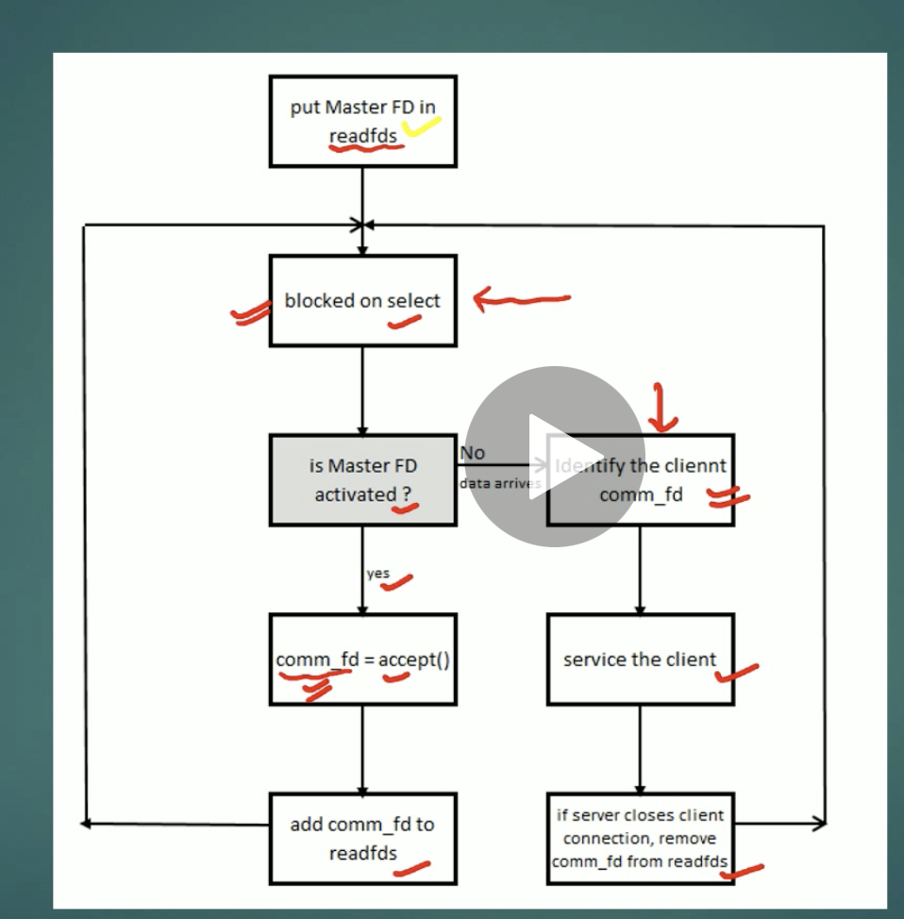

**2) IPC Using the “Message Queue”:**

**Enqueue: Inserting element into the queue , Dequeue: Poping an element from the queue:**

**Note:**  Message Queue is a Kernel resource means, its managed by Operating system.

a) Message Queue Concepts.

b) MsgQ Management APIs.

c) Using a MsgQ

d) Code Walk – Step by Step.

a) Processes running on same machine can exchange any data using message queues.

b) Process can create a new message queue or can use an existing message queue which was created by another process.

c) A message queue is uniquely identified by ID, No 2 MsgQs can have same Ids.

d) Message Queue resides and manage by the Kernel/OS

e) Sending process A can post data to the message queue, receiving process B reads data from the msqQ.

A Process can create a new msgQ or use an existing msgQ using the below API:

a) mqd_t mq_open(const char* name, int oflag)

b) mqd_t mq_open(const char* name, int oflag, mode_t mode, struct mq_attr *attr)

c) struct mq_attr {

long mq_flags; /* Flags: 0 */

long mq_maxmsg; /*Max # of messages on the queue */

long mq_msgsize; /* Max message size (bytes) */

long mq_curmsgs; /* # of messages currently in the queue */

}

**name** – Name of msgQ, eg: “/servermsq-q”

**oflags:**

i) O_RDONLY: Process can only read message from msgQ, but cannot write into it.

ii) O_WRONLY: Process can only write message from msgQ, but cannot read from it.

iii) O_RDWR: Process can read and write data into msgQ

iv) O_CREATE: The queue is created if not exist already

v) O_EXCL: mq_open fails if process tries to open an existing queue, this flag has no meaning if used alone , always used b OR-ing with O_CREAT flag.

vi) **mode**: Permissions set by the owning the process on queue, using 0660

if mq_open() succeeds ,it returns a file descriptor( a handle) to the msgQ, Using this handle, we perform all msgQ operations on the msgQ throughout the program.

**Message Queue Closing:**

A Process can close a msQ using below API:

**int mq_close(mqd_t msgQ). Return value: 0 – success, -1 failure**

a) After closing the msgQ, the process cannot use the msgQ unless it open it again using mq_open()

b) Operating system removes and destroys the msgQ if all processes using the msgQ have closed it.

c) OS maintains information regarding how many processing are sharing the same msgQ(invoked mq_open()) using a parameter called **REFERENCE COUNTING.**

d) When a kernel resource (msgQ in our example) is created for the 1st time by a process, then reference_count will be equal to 1. If some other process also opens it, then it increments by 1, if anyother process closes it, then reference counting decrements by 1.

e) When reference_count=0, kernel cleansups/destroys that kernel resource.

Remember, Kernel resource could be anything, it could be socket FD, msgQ FD etc.

**Enqueue a Message:**

A process can place a message in a message Queue using below API:

int mq_send(mqd_t msgQ, char *msg_ptr, size_t msg_len, unsigned int msg_prio);

//Return value , 0 – success, -1 == failure.

a) mq_send is for sending message to the queue referred by the descriptor mqd_t)

b) The msg_ptr points to the message buffer, msg_len is size of the message, whether it should be less than or equal to the messge size of the queue.

c) msg_prio is the message priority, which is non -ve number specifying the priority of the message.

Messages are placed in the queue in the decreasing order of the message priority, with the older messages for a priority before newer messages.

d) If the queue is full, msg_send blocks until there is a space on the queue, unless O_NONBLOCK flag is enabled for the queue, in which mq_send immediately return with an error set to EAGAIN.

**DEQUEUE a Message:**

msg_receive(mqd_t msgQ,

char* msg_ptr,

size_t msg_len,

unsigned int * msg_prio) /// Return. n_bytes of recvd messge – Success , -1 –failure.

a) The msg_ptr points to the empty message buffer, msg_len is size of the buffer in the bytes.

b) The oldest msg of the highest priority is deleted from the queue, passed to the process in the buffer pointed out by msg_ptr.

c) If the pointer msg_prio is not null, the priority of the received messge is stored in the integer pointed by it.

d) The default behavior of the mq_receive is to block if there is no message in the queue, However if O_NONBLOCK is enabled for the queue and queue is empty, mq_receive returns immediately with errorNo set to EAGAIN.

e) On Success, mq_receive returns the no. of bytes received in the buffer pointed by msg_ptr.

**Destroying a Message Queue:**

A Creating process can destroy a message Queue using below API:

int mq_unlink(const char* msgQ).

a) mq_unlink destroys the msgQ (release the Kernel resource)

b) Should be called when the process has involed the mq_close() on the msgQ.

c) return -1 if it fails, 0 on success.

d) Postpone if the other process using msgQ.

**IMPORTANT NOTES:**

a) A message queue IPC mechanism usually supports N:1 communication paradigm, meaning there can be N senders , but 1 receiver per message Queue.

b) Multiple senders can open the same msgQ using the msgQ name, and enque their messagea in re same queue.

c) Receiver process can deque the msgs from the msg Queue that was placed by different sender processes.

d) However, Receiving process can dequeue messages from different queues, at the same time.(Multiplexing using the select() system call).

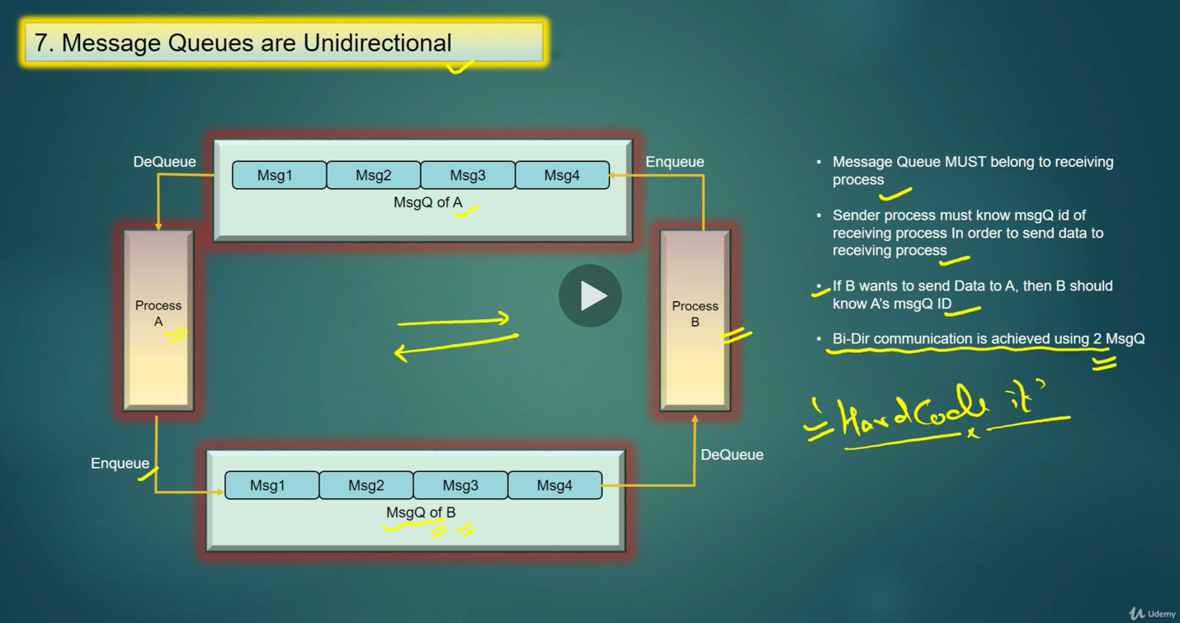

**IPC Technique: 2**

**Shared Memory:**

**IPC using the shared memory:**

**Shared Memory Overall Design:**

**Program Control Block:**

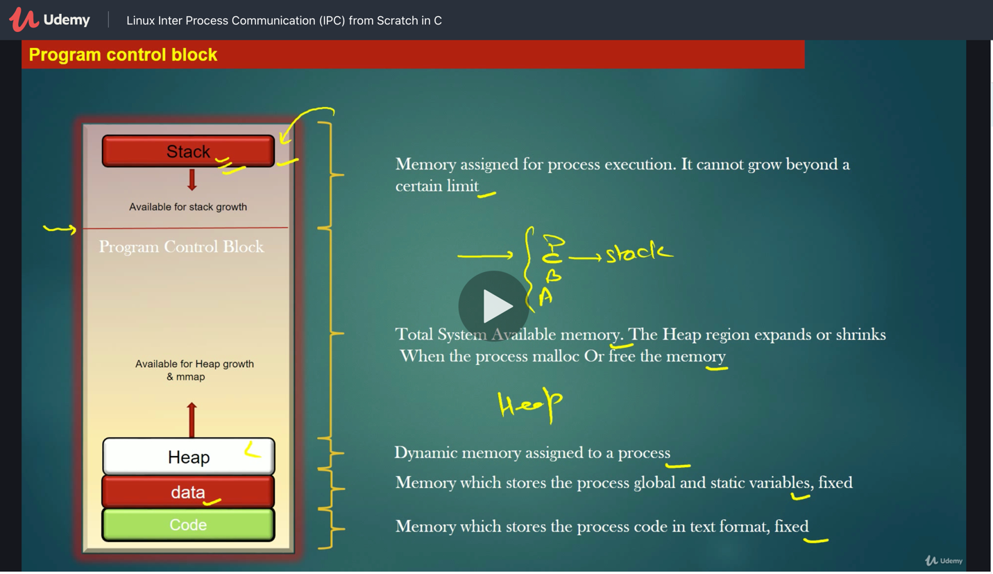

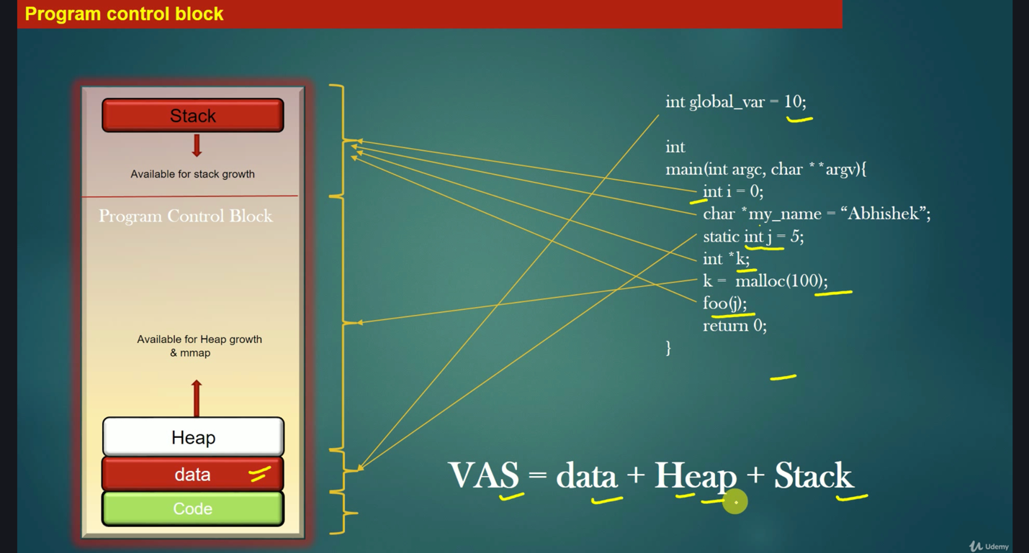

**VAS means Virtual Address Space.**

a) Shared memory is a chunk of Kernel Memory , No process is the owner of this memory.

b) In linux, when a process executes, it is assigned a chunk of virtual memory of the system. This chunk of Memory is called process’s Virtual address space.

c) A process can access only the memory addresses which lies within in VAS. If it tries to access the address which lies outside its VAS, Linux OS kills the proess (Segmentation fault).

d) So Thumb Rule is: A process is not allowed to read/write into memory which is outside its virtual memory region.

e) A process Virtual memory region grows and shinks as the process request more memory from OS or free the memory.

f) A given address which lies in Virtual memory region of process P1, has no meaning for any other process in the system.

**Kernel Memory:**

a) Kernel has its own memory called Kernel Memory.

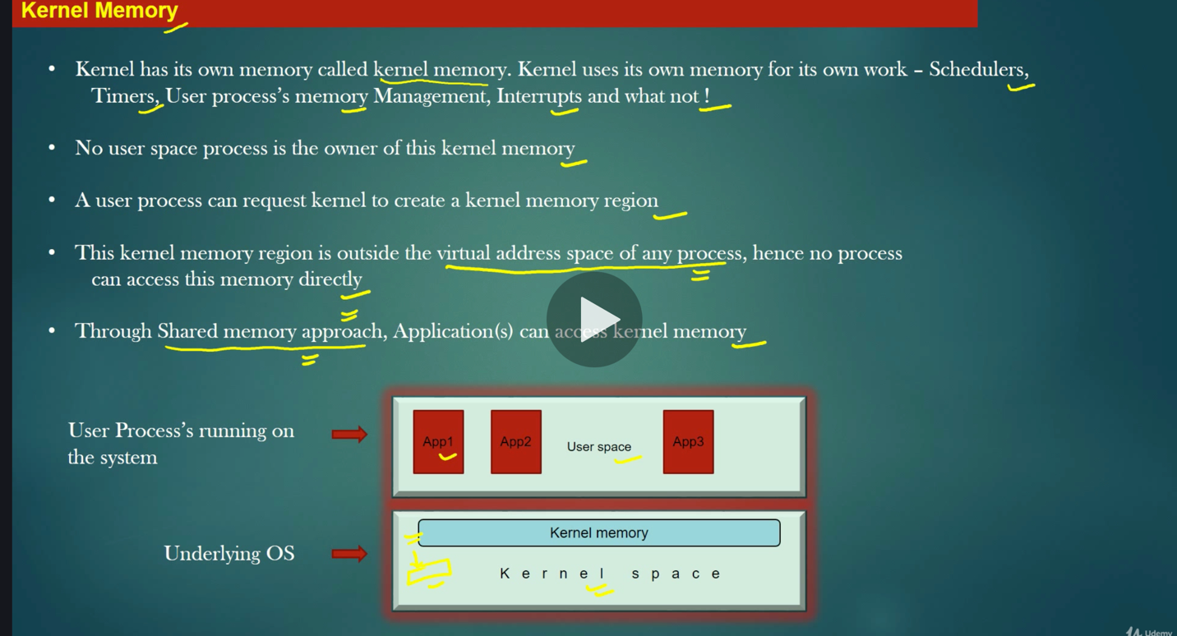

a) Kernel memory starting address: k, end address k’.

b) Size of Kernel memory to access: k’-k

c) Process request OS to expand its VAS by k’-k bytes, ie. k’-k new addresses are added to the process VAS from global VAS.

d) It does this using the **mmap** system call.

e) Now, Address in this newly created region are mapped by OS(paging) to the corresponding address of Kernel Memory.

f) Actual data/content continue to reside in Kernel Memory, not in new mmap region.

h) Data in Kernel memory is not moved, only address mappings is manipulated.

i) A and A1 are addresses of virtual memory address space of process. A maps to K, A1 maps to K’.

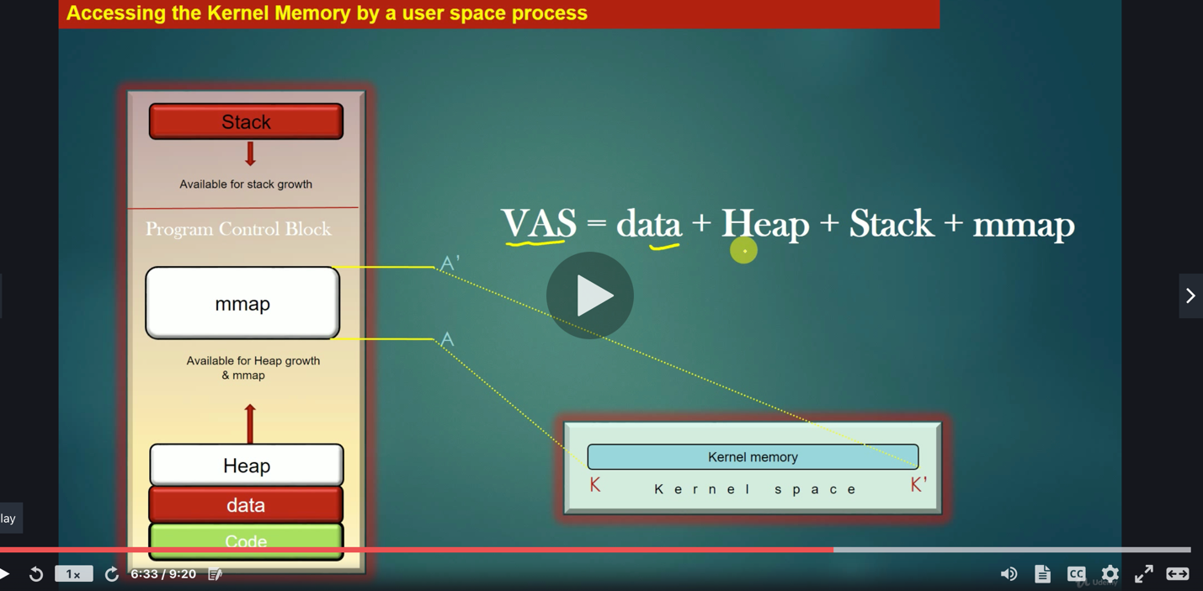

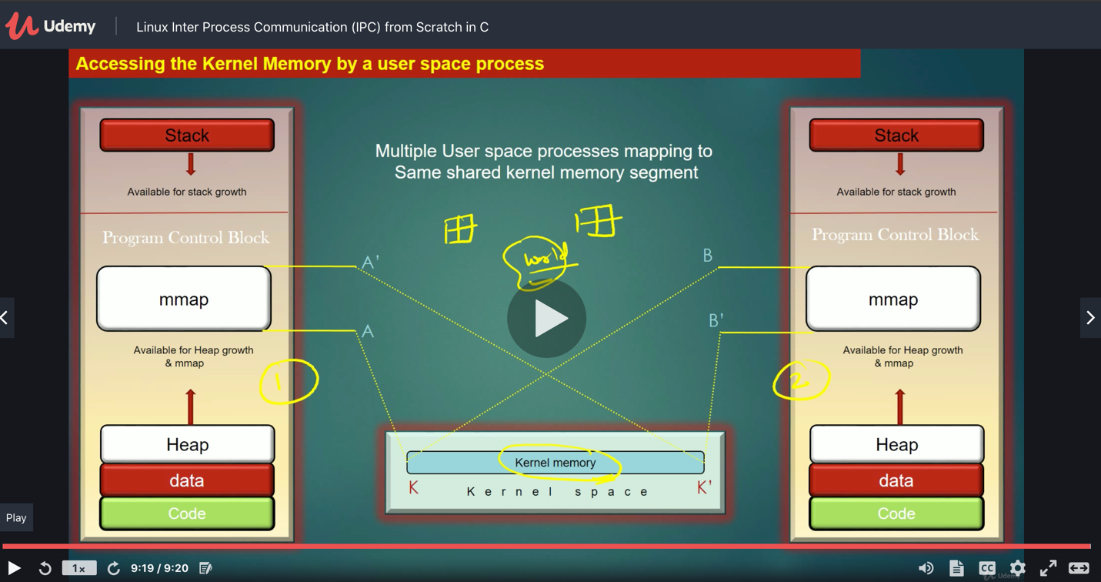

**Design Constraints for using Shared Memory as IPC:**

a) Exactly one process is responsible to update the shared memory(publisher process).

b) Rest of the processes only read the shared memory(Subscriber processes).

c) The frequency of updating the shared memory by publisher process should not be very high.

i)ex: Publisher process update the shared memory when user configure something on the software.

d) If multiple processes attempts to update the shared memory at the same time, then it may lead to “write-write conflict”:

i) We need to handle this situation using Mutex(Mutual exclusion) based synchronization.

ii) Synchronization comes at the cost of the performance

Because we put the threads to sleep (in addition to their natural CPU preemption) inorder to prevent concurrent access to critical section.

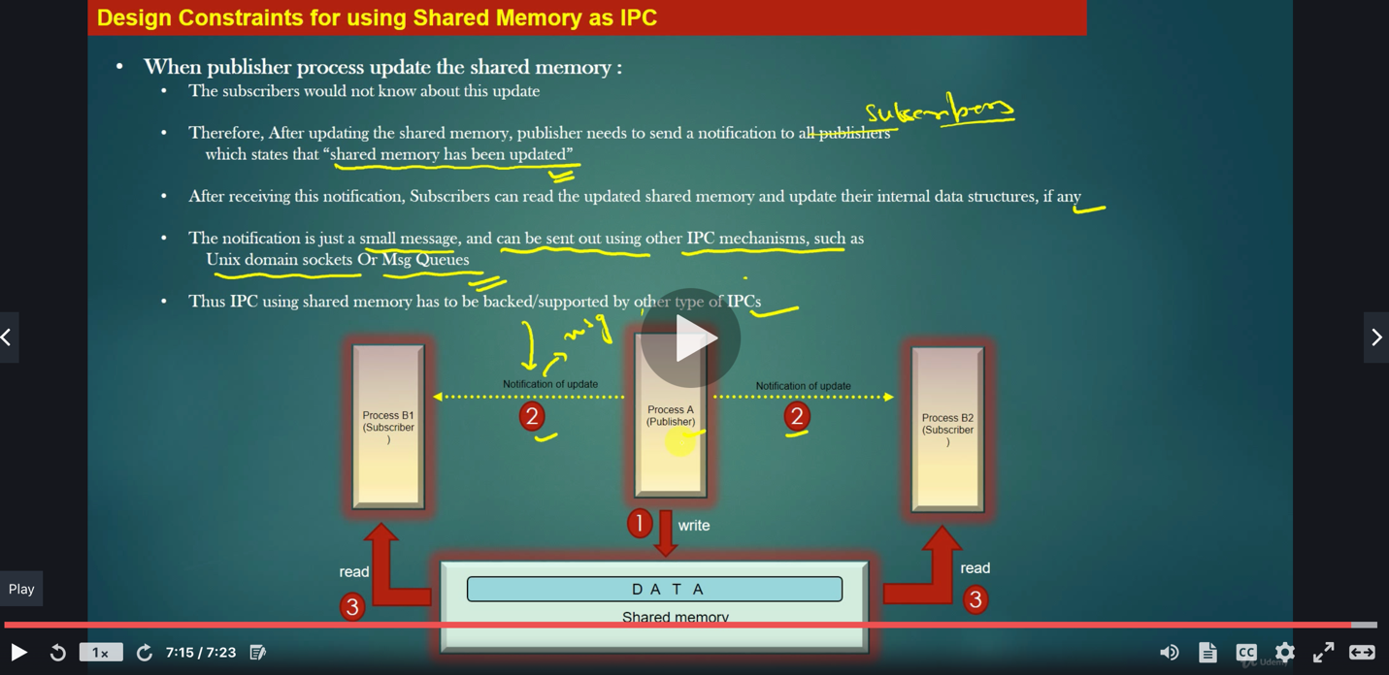

**Shared Memory APIs:**

a) Creating or Opening a Shared memory region:

int shm_open(const char* name, int oflag, mode_t mode)

name of shared memory should always start with “/”, Eg: “/DataSegment”

It returns a file descriptor.

oflag: *O_CREAT – Create a shared memory if it does not exist already*

*O_RDONLY – Open a shared memory in read only mode.*

*O_WRONLY – Open a shared memory object in write only mode.*

*O_RDWR – Open a shared memory object in read-write mode*

*O_APPEND – New data shall be appended to the existent content of shared memory.*

*O_TRUNC – It truncates the existing shared memory object, if already exists to zero bytes again.*

*O_EXCL flag is used to gether with the O_CREAT flag, the shm_open fails if shared memory object already exists with same name.*

*Ex: int fdsh = shm_open(“/DataSegemnt”, O_CREAT|O_RDONLY|O_TRUNC,0660);*

*A newly created shared memory object is of the size zero bytes.*

*It can be made of the desired size by using the* ***ftruncate*** *sytem call.*

**Setting the size of the shared memory Object:**

int ftruncate(int shm_fid, size_t new_size)

***Resize the shared memory object to new size.***

***Returns -1 on failure.***

***Should be called after shm_open if required.***

**MMAP API(Memory Mapping*):***

**a) Mapping the shared memory into process’s Virtual Address Space:**

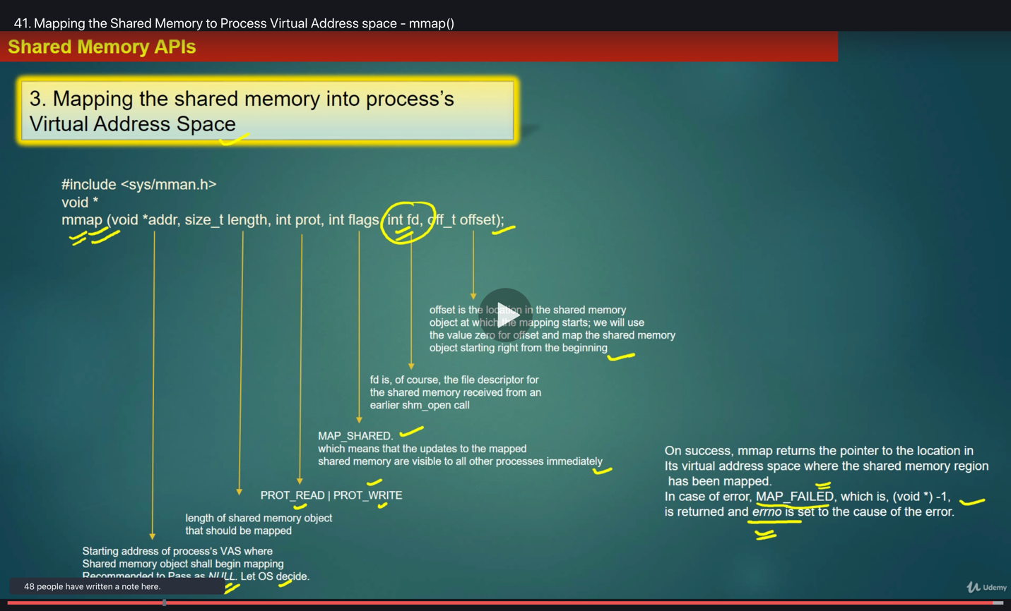

**UnMapping of the shared Memory:**

int munmap(void *addr, size_t length)

a) addr: Address in the process Virtual address space where Shared Memory has been mapped (staring end of the mapping ) or the (Return value of the mmap())

b) Unmapps the shared memory object at the location pointed out by addr and having size lengh

c) Returns -1 on failure, 0 on success.

d) It do not destroys the shared memory, it only destroy the mapping b/w the shared memory in Kernel Space and virtual memory of the process.

**Shared Memory Unlink:**

a) int shm_unlink(const char* name);

i) De-associate shared memory with its name

ii) It is equivant to like no shared memory with the same name exists anymore. The name shall be available to associate with new instance of shared memory.

iii) return -1 on error, 0 on success.

**Closing the Shared Memory file descriptor:**

int close(int shm_fd) :

a) Decreases the reference count of the shared memory object maintained in the Kernel Space.

b) If reference count decreases to zero, shared memory and its content is destroyed(on the same systems continue to exist until system is rebooted).

c) return -1 on error, 0 on success.

**Signals:**

a) Signals are sent from the OS to a Process(in the User Space).

b( Signals are sent from the Process to Process)

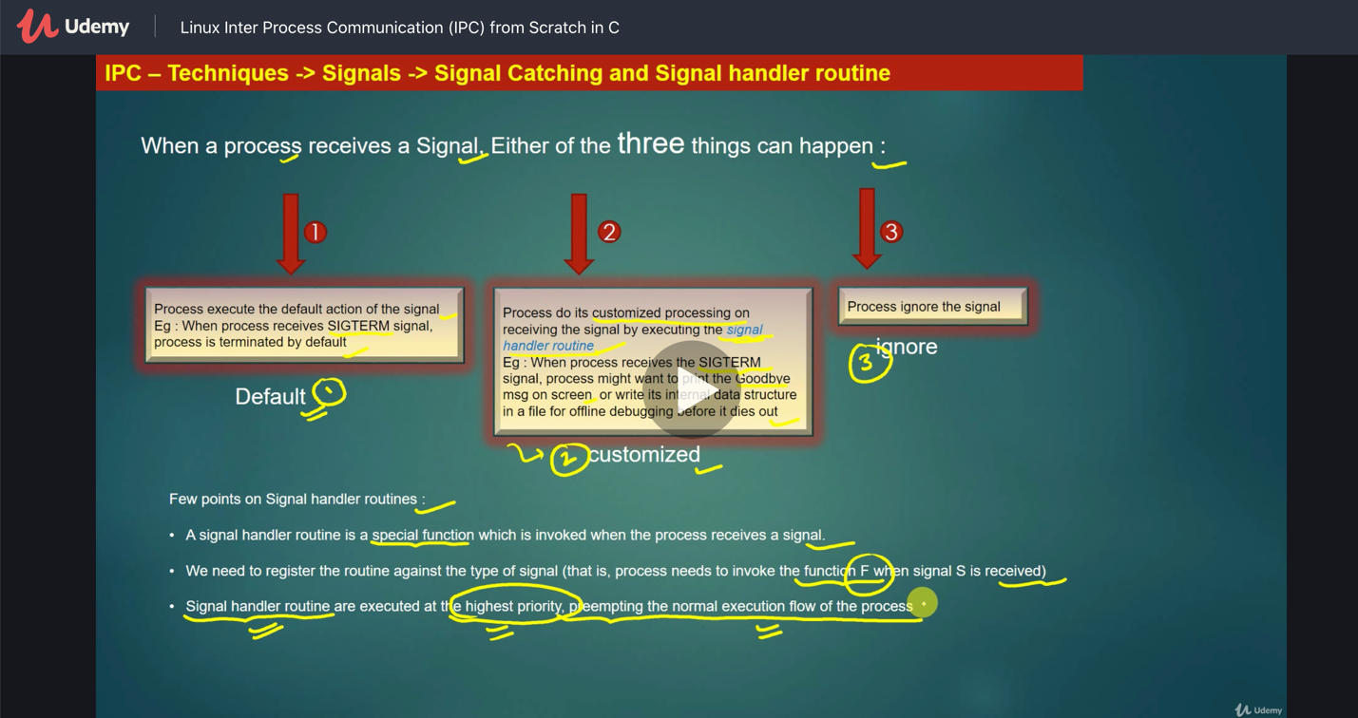

**Well Known Signals in Linux:**

a) SIGINT – interrupt (i.e Ctrl-C)

b) SIGUSR1 and SIGUSR2 – User defined Signals. (p1 to p2)